Industrial Short Course

on
Economic Process Design, Operation
and Plantwide Control

A Practical Approach with HYSYS/ASPEN

1-5 June

Class Presentations

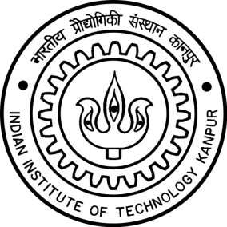

Course Coordinator

Dr. Nitin Kaistha
Professor
Department of Chemical Engineering
Indian Institute of Technology Kanpur, INDIA

