**Emnemodul: Advanced Process Control**

**02 Dec. 2015. Time: 0915 – 1200.**

**Answer as carefully as possible, preferably using the available space.**

You may answer in Norwegian, however English is preferred.

**Problem 1 (15%)**

1. What are the steps in the top-down procedure of the plantwide control procedure from Skogestad?
2. Explain what is done in each step of part a.
3. What is the “throughput manipulator”?
4. Where should the throughput manipulator be placed? What is this point called? Discuss why you suggest to place it at this position.
5. Define what a consistent inventory control structure is. When is a consistent control structure locally consistent?

**Problem 2 (25%)**

1. Define self-optimizing control
2. What is meant by the rule: “Avoid product give-away”
3. What are active constraints, and why should we always control them?
4. You have decided to control a measurement combination  . You choose **H** such that .
   1. What is *F*, and why did you chose this particular H?
   2. Under what conditions is the resulting H optimal?
5. Given a process with , and one steady-state degree of freedom u. Calculate the optimal measurement combination using the null-space method.
6. What are the advantages of the “exact local method” compared to the null-space method?
7. Givenfrom part e, and . Give the formula for the optimal. What is Y? What is the optimal measurement combination when we use the exact local method? Hint: .
8. Would you consider the application of the exact local method in this case as useful? Justify your answer.
9. One of Sigurd’s pairing rules for decentralized control is “Pair a MV that may (optimally) saturate with a CV that may be given up”. Why do you think that is a good idea?
10. What is meant by the expression “squeeze and shift”? Explain!

**Problem 3 (20%)**

1. What is the control structure shown below called?

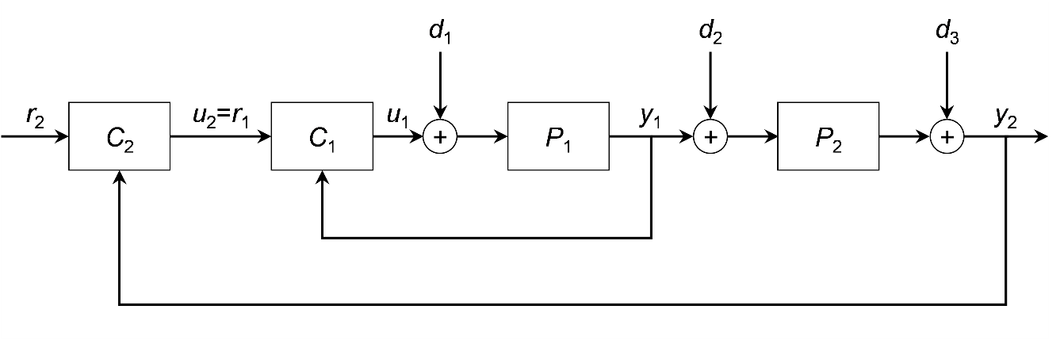

1. When is such a structure expected to perform better than a single control loop using only C2 (just imagine the figure in part a without the control loop C1). Explain!
2. What is “input-resetting”/”valve position control/midranging control” when is it used? Explain the concept using a block diagram. When would you consider using it?
3. Give an example for split-range control. When would you consider using it?

**Problem 4 (10%)**

1. We have given the following process:



Using the half-rule, give a first order + dead-time approximation of the process.

1. Using , what are the SIMC parameters for a PI controller for this process.
2. What are the SIMC parameters () for a PID controller for this process? Does it make sense to use a PID controller in this case?

**Problem 5 (10 %)**

Which of the following configurations are consistent? Indicate if they are local or global consistent. Justify your answers.

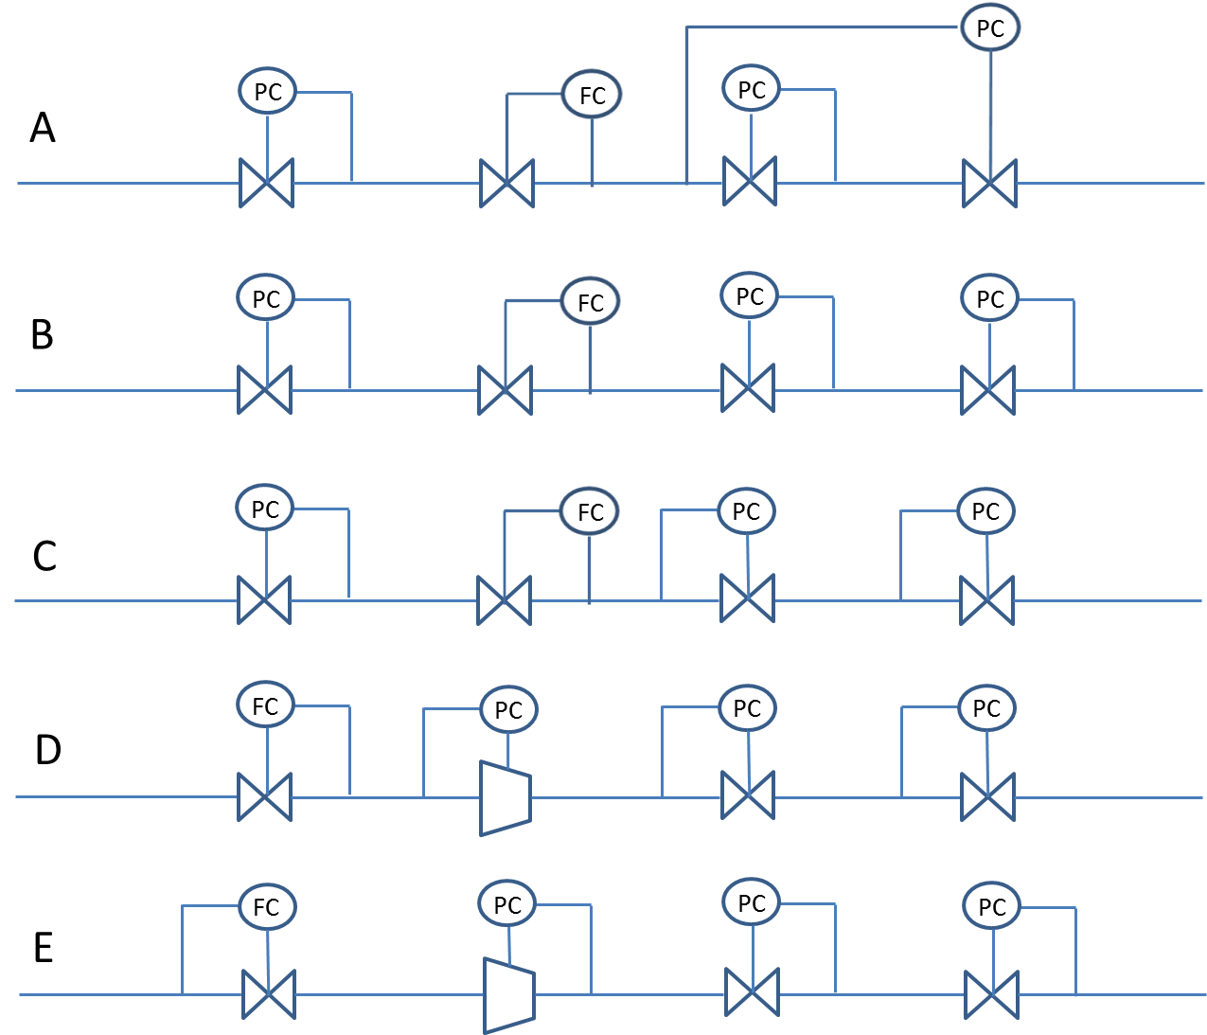

**Problem 6 (20 %)**

You are considering a sequence of distillation columns for separating three components A,B,C, see figure below.

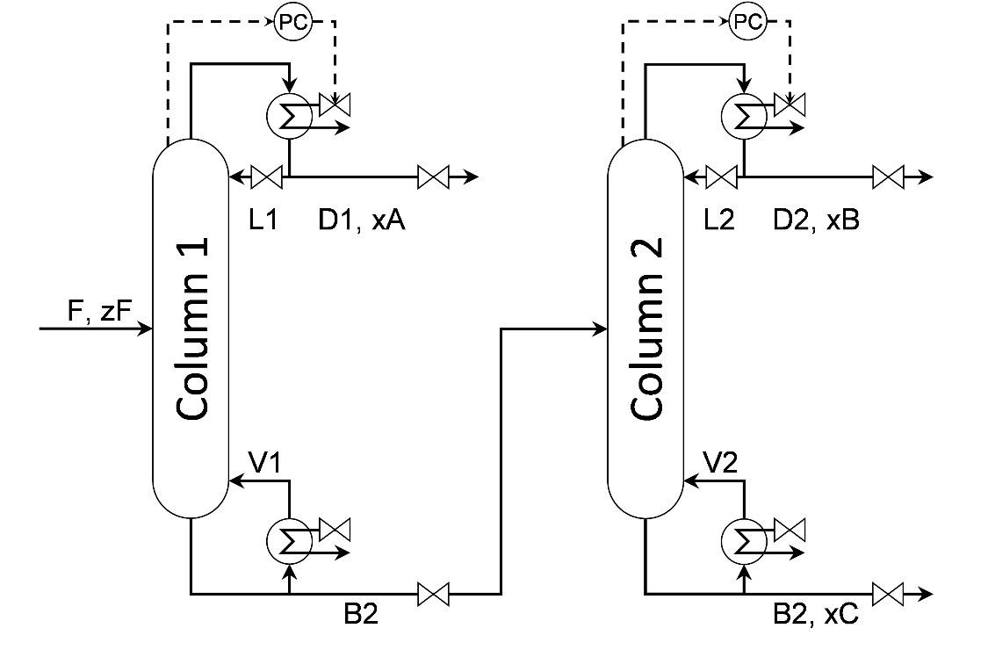

Talking to the plant manager, the objective is to minimize the operation cost

,

Where denotes the price for quantity, and the capital letters denote the streams. The values for the prices are:



The plant manager mentions to you that during some periods the energy price is very low  
(), and during other periods  is high ()

The plant manager further tells you that there are constraints that have to be obeyed during operation



The feed  is given by the operation conditions of the upstream process.

1. How many dynamic and steady state degrees of freedom does the process have?
2. Based on your experience and engineering knowhow, which constraints will be active when the **energy price is very low**, . Justify your answer.
3. Based on your experience and engineering knowhow, which constraints will be active when the **energy price is very high**, . Justify your answer.
4. The plant manager tells you that the energy price is usually very low   
   (). Propose a control structure for this case. Draw it into the figure below, and explain your choices.

