Comments on paper:
Skogestad, S., Zotica, C., & Alsop, N. (2023). Transformed inputs for linearization, decoupling and feedforward controller. Journal of process Control, 122, 113–133.

By Sigurd Skogestad

5.4 Example 6: Heat exchanger example
(17 nov- 2023 based on discussion with Krister Forsman)
The transformed input v_0w based om measuring w=T2 is
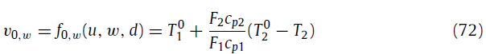
The same idea is found in Fig. 8-50 in Perry (1999). Note here that 2 is the upper stream and 1 the lower stream, so Q=F2(T20-T2).
Her is from Perry:
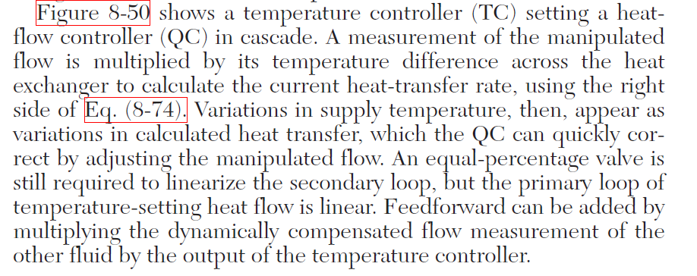
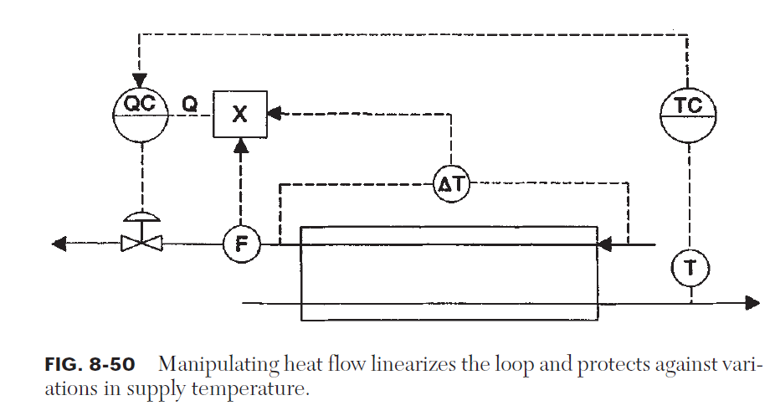
I think Perry also includes the feedforward action from F1, because they write:
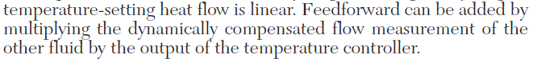
F1 = “flow measurement of the other fluid”
Let Qs be the output from the temperature controller Then, because of the feedback, multiplying Qs by F1 has the same effect as dividing Q by F1. The only part Perry is then missing is the feedforward from the inlet temperature T10.

Blending example and comments by Seborg et al.
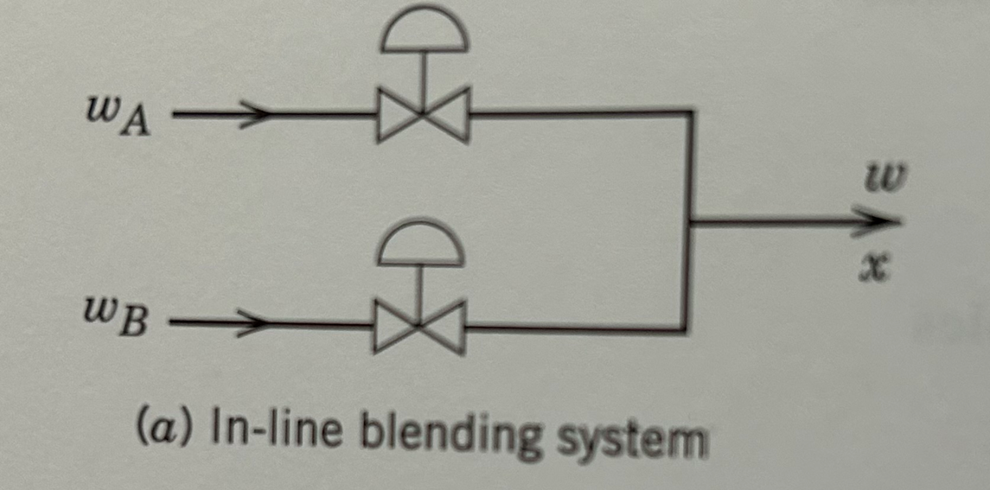
Consider a blending system where we mix component (A) and water (B) and we want to control total flow w and mass fraction of the product x.
So y = [w,x] and u=[wA, wB].
The steady-state model y = f0(u) is
Total mass: w = wA + wB
Component A: x = wA/w
Introduce transformed inputs
(1a) v01 = wA+wB
(1b) v02=wA/(wA+wB).
The transformed system becomes
(2) y=I v0 ,
so it is as expected decoupled. This is a general result!!
Based on (2), Seborg et al. (2016, page 343; 2012, page page 502) write about the choice of transformed manipulated variables in (1): ‘‘This means that the controlled variables are identical to the manipulated variables! Thus, the gain matrix is the identity matrix, and the two control loops do not interact at all. This situation is fortuitous, and also unusual, because it is seldom possible to choose manipulated variables that are, in fact, the controlled variables’’.
Nooo… , in this paper we have shown that the statement that this is ‘‘fortuitous, and also un-usual’’ is not correct. If we assume that the disturbances are measured (for this particular example there were none), then it is always possible to derive ideal transformed manipulated variables (inputs) 𝑣0 which are equal to the controlled variables 𝑦, simply by choosing 𝑣0 as the right-hand side of the steady-state model equations.

