Comments on paper: Sigurd Skogestad, ''Advanced control using decomposition and simple elements'', *Annual Reviews in Control,* **vol. 56** (2023), Article 100903.

**Comment 1 : Correction of reference for hierarchical decomposition**

**Comment 2. (Des. 2023) Perry (1973) has an early description of predictive control.**

**Comment 3. (Des. 2023) Perry (1999) gives an example of the use of transformed inputs for linearization and feedforward (E14)**

**Comment 4. Older reference for separate controllers with different setpoints”; E6, (March 2024).**

**Comment 5. One more split range control (SRC) scheme for MV-MV switching (The 4th alternative)**

**Comment 1** Correction of reference for hierarchical decomposition **(Des. 2023). Re Figure 4 (decomposition into layers).**

In the paper it is referred to Richalet et al. (Automatica, 1978) but in that paper there is actually no such figure, so this must be a misprint. However, Perry’s handbook (1973) has the following similar figure:

**Comment 2. (Des. 2023) Perry (1973) also has an early description of predictive control:**

**Comment 3. (Des. 2023) Perry (1999) gives an example of the use of transformed inputs for linearization and feedforward (E14) for a heat exchanger (the heat exchanger example is discussed in more detail in the paper by Skogestad, Zotica and Alsop (JPC, 2023).**



**Comment 4. Older reference for separate controllers with different setpoints”; E6, (March 2024).**

In my paper, the oldest reference I give for using “separate controllers with different setpoints”; E6, Fig. 22) for MV-MV switching is the book by Smith (2010) (page 86) (see below).The name “separate controllers” is used by Smith (2010). However, this scheme has obviously used in industry long before this. For example, an older reference is the book by **Forsman (2005) (in Swedish)** (page 152-153).

In the section title (and also in the flowsheet, see his Figure 6.28) Forsman calls it “Many controllers with the same CV” (similar to what I call it based on Smith (2000), but in the corresponding block diagram (Figure 6.29) he calls it “Parallel control”. However, I have used the term “parallel control” for the case where both controllers have the same setpoint and are used all the same time. On the other hand, in Figure 22 (“separate controllers”) they are used sequentially (one at a time), that is, only when u1 is saturated do we start using u2.

So maybe it is better to call “separate controllers with different setpoints” (E6, Fig. 22) for “**Sequential parallel control”?** This would also make it possible to distinguish between the two similar schemes for VPC. We could call “VPC on extra dynamic input” (E3, Fig. 12) for simply “VPC” and “VPC on main steady-state input” (for MV-MV switching) (E7, Fig. 24) for “Sequential VPC” (for MV-MV switching). Comments?

Some more details on Comment 4:

**This is from my paper (just a reminder):**

This shows the two VPC schemes. Left is “standard VPC” (E3, Fig.12) and right is “sequential VPC” (E7, Fig.24)

**This is what Smith (2010) writes on page 86:**



**Here is from the book by Forsman (in Swedish), pages 152-153.**

Krister Forsman, «Reglerteknik för processindustrin», Studentlitetratur, 2005

End Comment 4

**Comment 5 One more split range control (SRC) scheme (Alternative 4) is shown in Figure 3 below:**

This is not a really a new scheme, as it is really just another implementation of conventional SRC (see Fig. 3) and Shinskey has used it before (see below), and Evren Turan has rediscovered it (see Figure 2) and Sigurd added a little (to get Figure 3)

It requires a selector (to subtract the actual value of u2 from u2’ to get u1=u2’-u2)and  thus it is very nice to combine with cases where we anyway need a min-selector (see Shibnskey and see Fig. 1/2 below)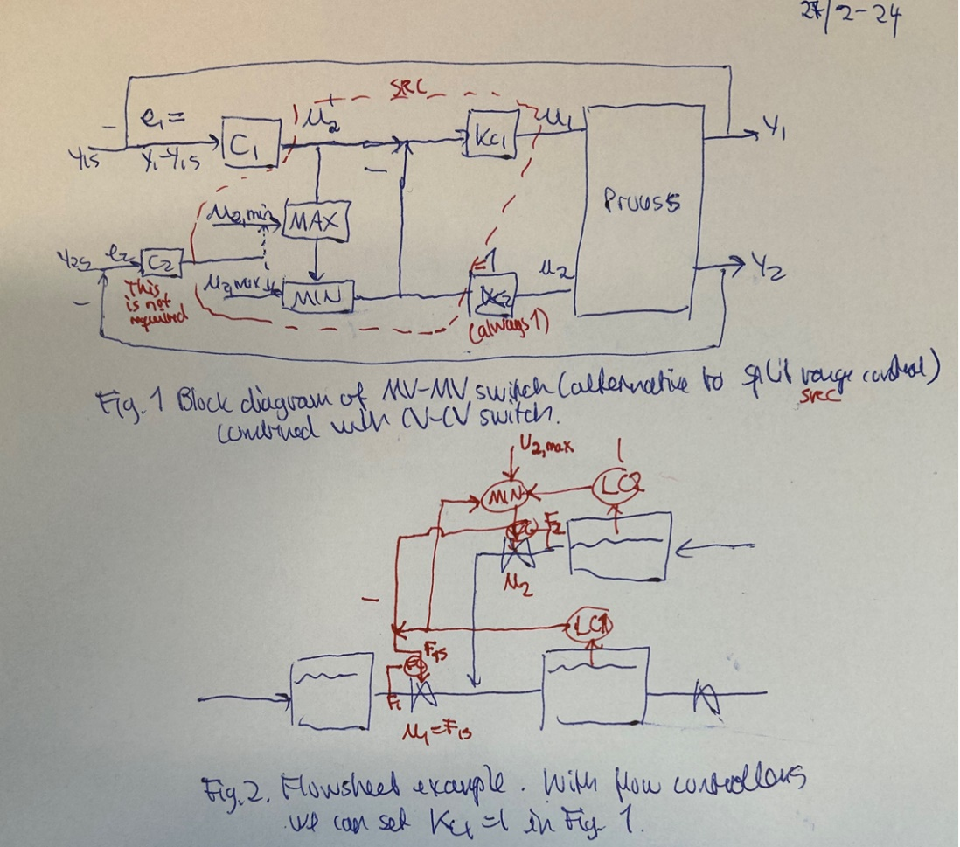

e

Here is from Reyes-Luas and Skogestad (2020) where we refer to Shinskey.

**End Comment 5.**