Model Predictive Control for the Self-optimized Operation in Wastewater Treatment Plants

Mario Franciscoa*, Sigurd Skogestadb, Pastora Vegac

a Dept of Computing and Automation. University of Salamanca. 37700 Béjar, Spain

bDept. of Chemical Engineering, Norwegian University of Science and Technology. N-7491 Trondheim, Norway.

cDept. of Computing and Automation.Univ. of Salamanca. 37008, Salamanca,Spain

mfs@usal.es

Abstract

This paper describes a procedure to find the best economically controlled variables for the activated sludge process in a wastewater treatment plant despite the load disturbances. A further controllability analysis of those variables including a nonlinear model predictive controller (NMPC) has been performed. The self-optimizing methodology has been applied, considering the most important measurements of the process. A first pre-screening of those measurements has been done based on the nonlinear model of the process and typical disturbances, in order to avoid non feasible operation. The NMPC performance has been compared with a distributed NMPC-PI structure.

**Keywords**: self-optimizing control; model predictive control; wastewater treatment plant

* 1. Introduction

The efficiency of most wastewater treatment plants (WWTP) is an important issue that must be improved. In order to fulfil the effluent legal requirements for all weather conditions, which generate large variations of the influent, the operating costs are usually higher than the actually needed. Therefore, the optimization of the WWTP operation can provide a significant cost reduction. In the existing literature, most works only consider the problem from a heuristic viewpoint or stating a particular optimization problem. Only Araujo et al. (2013) provides a comprehensive approach, performing a sensitivity analysis of optimal operation. In Francisco et al. (2011) the process is optimized offline but including also plant design.

In order to minimize the economic loss when disturbances occur, one approach is the re-optimization of the plant by applying Real Time Optimization techniques which can be very demanding computationally, or perform some set point optimization off-line. In this work, a different approach is considered, called self-optimizing control (SOC) (Skogestad, 2000), which consists of determining some primary controlled variables (CVs), also called self-optimized variables, and their corresponding set points, that when kept constant, the economic loss is small with respect to costs if the operation is re-optimized. Although there are many successful works of SOC (see e.g. Umar et al., 2012) the dynamic validation of the results is usually performed by means of decentralized PI controllers (Araujo and Skogestad, 2008).

The first objective of this work is to find the self-optimized variables in a WWTP as a combination of measurements, and the second objective is to evaluate the dynamic behavior of those variables by implementing two control structures: a centralized nonlinear multivariable model predictive controller (NMPC) and a distributed control structure with an NMPC and local PI controllers. The methodology explained has been applied to the activated sludge process using the Benchmark Simulation Model No. 1 (BSM1) (Alex et al., 2008).

* 1. Local methods for self-optimizing control

The controlled variables selection, particularly for SOC, is a fundamental issue within the plant-wide design. The first step of the methodology is the determination of the optimal operation, assuming here that the economics of the plant are primarily determined by steady state behavior. The following problem is solved, considering nominal disturbances:

 (1)

subject to:

;

where **x** is the state vector, **u**0is the manipulated variables vector (degrees of freedom), **d** isthe disturbances vector, **g**1is a vector function representing the process model equations and **g**2 the process constraints. The active constraints found when solving problem (1) must be controlled tightly for optimal operation (active constraints control), and in this work it is assumed that the set of active constraints does not change for all typical disturbances.

Then, the identification of as many economic controlled variables as the number of remaining degrees of freedom is performed, by using the SOC methodology explained below. The selection is based on the Taylor expansion of the loss function around the equilibrium nominal point **u***opt*(**d**):

 (2)

where *Jc* is the cost value when the set point is kept constant, and *Jopt* is the optimum cost re-optimizing for the corresponding **d**, **u***opt* is the optimum value for **u** and **J***uu* is the Hessian of the cost function.

In order to achieve near-optimal operation without the need to re-optimize the process when disturbances occur, the loss must be minimized. Although CV can be selected as a subset of the available measurements, lower loss is achieved by selecting CV as linear combinations of measurements. For that reason, a combination matrix **H** with real coefficients is defined as , where **c**is the vector of controlled variables and **y**is the vector of available independent measurements, that can include manipulated variables (e.g. flow rate measurements) or measured disturbances. The matrix **H** can be found through minimization of the following expression (Halvorsen et al., 2003; Alstad et al., 2009):

 (3)

where  ; ;, **W***d* and **W***e* are scaling matrices for disturbances and implementation errors, and are the process transfer matrices (linearized model) , and **J**uu, **J**ud are the hessians.

For problem (3), explicit solutions have been developed, where **Q** is any nonsingular matrix of nc x nc (nc = No. of controlled variables) (Yelchuru and Skogestad, 2011)

 (4)

* 1. Methodology applied to the BSM1
     1. Description of the process

The benchmark simulation model nº 1 (BSM1) (Alex et al., 2008) has been used as a standard activated sludge process model in a WWTP for performance assessment of control strategies and optimization. It consists of five biological reactors connected in series and one secondary settler. The reactors are modeled according to mass balances described in the Activated Sludge Model nº 1 (ASM1), developed by the IWAQ (International Association on Water Quality). An internal recycle (*Qa*) from the last tank to the first one is used to supply the denitrification step with nitrate. In order to maintain the microbiological population, sludge from the settler is recirculated into the reactors by means of an external recycle (*Qr*), and sludge excess is purged from the bottom of the settler (*Qw*). Note that in this benchmark no pH control is considered. More details are given in Alex et al. (2008).

* + 1. Operational objectives and constraints

The operational objectives of the WWTP include operational costs and other process and regulations constraints. The cost defined in Alex et al. (2008) has been considered:

 (5)

where *PE* is the pumping energy, *AE* is the aeration energy, *ME* is the mixing energy, *SP* is the sludge production, and *kE*, *kD* are the weights representing prices. The constraints needed for process operability are listed in table 1, where *CODe* is the chemical oxygen demand, *BOD5,e* is the 5 day biological oxygen demand, *TSSe* is the total suspended solids concentration, and *TNe* is the total nitrogen concentration, all measured in the effluent.

For the BSM1 there are eight manipulated variables that correspond to eight degrees of freedom (**u**): *Qa*, *Qr,* *Qw*, *KLa*(1-5). The disturbances selected are some of the most important inputs to the plant: *Q(in)*, *COD(in)*, *TSS(in)*. *TN(in)* is not considered in the methodology in order to simplify the results, but it is inclusion is straightforward. The weather profile events specified in the BSM1 derive the following disturbance vectors: **d***0* corresponds to the nominal load conditions, **d***1* are the average load values during the rainy weather, **d***2* are the average values only for a rain event (extracted from the rain BSM1 disturbances), **d***3* are the average during the whole period for storms, **d***42* are the average values during a storm, **d***5*are the average values for one year with average temperature.

Table 1: Process constraints

|  |  |  |
| --- | --- | --- |
| Effluent constraints and constraints on manipulated variables | | |
| (gCOD/m3) | (gSS/m3) | (m3/d) |
| (gBOD/m3) | (gN/m3) | (m3/d) |
| (gN/m3) | (1/d) | (m3/d) |

The nominal optimal operating point has been obtained solving problem (1) for the WWTP, considering cost function (5) and constraints of table 1. This optimization has also been performed for different disturbances, always showing the same three active constraints *Qa* (m3/d)=0, *SNH_e* (g/m3)=4, *TSSe* (g/m3)=30. Two of them are output active constraints, so they will be linked to two degrees of freedom, remaining 5 available degrees of freedom.

For the selection of the five self-optimized variables, the Eq. (4) with matrix **Q** selected as the identity has been considered to obtain the corresponding matrix **H**. The initial set of measurements selected has been taken out of Alex et al. (2008), adding also the inputs and disturbances as measurements. In this work, a previous selection of measurements has been performed, very useful to avoid infeasibilities for the CV variables selected later (Larsson et al., 2001). The economic losses have been calculated with Eq. (2) for different weather conditions using the nonlinear model of the process, considering individual measurements. The primary CV candidate variables that make the process infeasible for some load disturbances have been removed, which are in this case for all reactors. Then, based on this study, several sets of measurements have been considered, giving different combination matrices **H**. In order to select the most suitable, as SOC procedure is local, nonlinear losses have been obtained for each set (Table 2) and only **H3** gives feasible solutions for all disturbances.

Set 1 (**H***1*): 

Set 2 (**H***2*): 

Set 3 (**H***3*): 

Table 2: Nonlinear losses for different combination matrices and disturbances

|  |  |  |  |  |  |  |
| --- | --- | --- | --- | --- | --- | --- |
|  | **d*1*** | **d*2*** | **d*3*** | **d*42*** | **d*43*** | **d*5*** |
| **H*1*** | Infeas | Infeas | Infeas | Infeas | Infeas | Infeas |
| **H*2*** | 0.223 | Infeas | 0.127 | Infeas | Infeas | 1.229 |
| **H*3*** | 0.038 | 0.627 | 0.069 | 1.182 | 0.821 | 0.300 |

* 1. Process controllability analysis

In this section, the dynamic behavior of the selected CV as combination of measurements defined by **H*3*** is evaluated. This study is important in order to validate the possible implementation of a controller which keeps the selected CV at optimal set points in spite of influent disturbances. The first control structure considered is a centralized multivariable nonlinear constrained MPC for controlling the active constraints and the self-optimized variables, with the full BSM1 as internal prediction model, and the following objective function:

**where **y** are the controlled outputs, **u** the manipulated variables and **r** the reference, *k* denotes the current sampling point,  is the predicted output at time *k+i*, depending of measurements up to time *k*,  are the changes in the manipulated variables, *Hc* is the control horizon, *Hw* and *Hp* are the initial and final prediction horizons respectively, **R** and **Q** are positive definite constant matrices, and **P** is the terminal weight. A second control structure with two PI controllers for the active constraints and the NMPC to control the self-optimized variables has been considered. This control structure has the advantage that if the MPC fails, the PI controllers still keep set points for the active constraints. For selecting a good pairing for the PIs, the RGA matrix has been studied; *TSSe* is controlled with *Qw* and *SNH,e* is controlled with *KLa*(5).

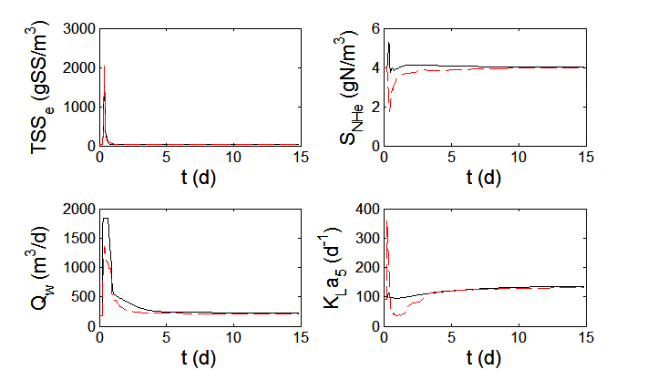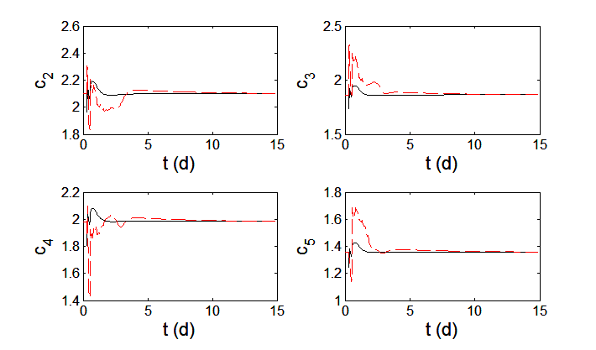

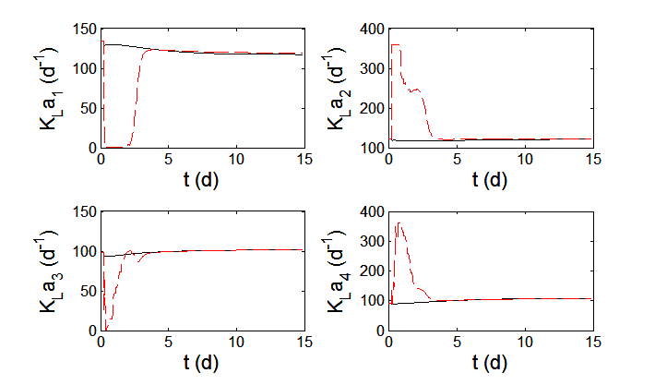

Figure 1: Control performance comparison of NMPC-PI control structure (solid line) and centralized NMPC (dashed line) for rain event disturbance (**d***2*) at t=0. Active constraints control (top left), self-optimized variables (top right) and manipulated variables (bottom).

In Fig. 1 the dynamic responses are presented, comparing the performance of the control structures when a **d***2* step disturbance is applied. They show a good set point tracking both for active constraints and selfoptimized variables, with reasonable control actions. The selfoptimized variable *c1* is not presented because its significance in costs is negligible. The tuning of the NMPC has been performed by trial and error procedure, choosing = diag(0.1 1 0.001 2 2 2 2) and = diag(0.1 0.014 0.014 0.014 0.014 0.014 0.005) for the centralized NMPC; and = diag(0.001 2 2 2 2), = diag(0.05 0.01 0.01 0.01 0.01) for the distributed NMPC-PI control. The horizons for both control structures are, and.The tuning parameters for the PI control No.1 are *Kp*= -54.8,*Ti*= -27.4 and *Kp*= -12,*Ti*= -0.2 for No. 2, the first one selected by SIMC guidelines (Skogestad, 2003). For simplicity in the comparative dynamic analysis, the manipulated variables have not been considered in the linear combinations determined by **H*3*.**

* 1. Conclusions

In this work, the SOC methodology has been applied to find the optimum controlled variables as a combination of measurements in a WWTP. A previous prescreening of measurements to avoid unfeasibilites for large load disturbances has been performed. The dynamic controllability of these variables has also been studied, by implementing two control structures. The results show that both control structures give good set point tracking, despite of a long transient due to the slow process dynamics, particularly for the most severe disturbances. The distributed MPC-PI control shows better transient, particularly for large disturbances, because of the separate treatment of the different time scales of the process and the easier tuning compared to the centralized NMPC.

References

J. Alex, L. Benedetti, J. Copp, K. Gernaey, U. Jeppsson, I. Nopens, M. Pons, L. Rieger, C. Rosen, J. Steyer, P. Vanrolleghem, S. Winkler, 2008, Benchmark Simulation Model no. 1 (BSM1), IWA Taskgroup on benchmarking of control strategies for WWTPs. Dpt. of Industrial Electrical Engineering and Automation, Lund University. Cod.: LUTEDX-TEIE 7229. 1-62.

V. Alstad, S. Skogestad, E.S. Hori., 2009, Optimal measurement combinations as controlled variables, Journal of Process Control,19, 138-148.

A. Araujo, S. Skogestad, 2008, Control structure design for the ammonia synthesis process, Computers and Chemical Engineering*,* 32, 2920-2932.

A. Araujo, S. Gallani, M. Mulas, S. Skogestad, 2013, Sensitivity Analysis of Optimal Operation of an Activated Sludge Process Model for Economic Controlled Variable Selection, Ind. Eng. Chem. Res*.*, 52 (29), 9908-9921.

M. Francisco, P. Vega, H. Álvarez, 2011, Robust Integrated Design of Processes with terminal penalty model predictive controllers, Chemical Engineering Research and Design, 89, 1011-1024.

I. J. Halvorsen, S. Skogestad, J. C. Morud, V. Alstad, 2003, Optimal Selection of Controlled Variables. Ind. Eng. Chem. Res., 42, 3273-3284.

T. Larsson, K. Hestetun, E. Hovland, S.Skogestad, 2001, Self-Optimizing Control of a Large-Scale Plant: The Tennessee Eastman Process, Ind. Eng. Chem. Res., 40, 4889-4901.

S. Skogestad, 2000, Plantwide control: The search for the self-optimizing control structure, J. of Process Control, 10, 487-507.

S. Skogestad, 2003, Simple analytic rules for model reduction and PID controller tuning, Journal of Process Control, 13, 291–309.

L. M. Umar, W. Hu, Y. Cao, V. Kariwala, 2012, Selection of Controlled Variables using self-optimizing Control Method: Recent Developments and Applications (eds G. P. Rangaiah and V. Kariwala), John Wiley & Sons, Ltd, Chichester, UK.

R. Yelchuru, S. Skogestad, 2011, Optimal Controlled Variable Selection with structural constraints using MIQP formulations, 18th IFAC World Congress (Milano, Italy).