Dividing wall columns for heterogeneous azeotropic distillation

Quang-Khoa Le¹, Ivar J. Halvorsen², Oleg Pajalic^{3,} Sigurd Skogestad^{1*}
¹Norwegian University of Science and Technology (NTNU), Trondheim, Norway;
²SINTEF, Trondheim, Norway; ³Perstorp AB, Perstorp, Sweden. *skoge@ntnu.no

Abstract
The aim of this work is to implement heterogeneous azeotropic distillation schemes in a dividing wall column (DWC) for a feed mixture of water (W), acetic acid (HAC) and an organic component (X). The original design makes use of X to act as an entrainer to facilitate the separation of water and HAC, and we also propose a DWC design based on this idea. This DWC design reduces the capital cost, but the energy usage is almost unchanged. To achieve energy savings and further reductions in capital costs, we need to use a Petlyuk DWC. We introduce isobutyl acetate (IBA) as an additional entrainer for the Petlyuk DWC, and achieve energy savings of about 20%.

Keywords
Dividing Wall Column (DWC), heterogenous azeotropic distillation, Petlyuk arrangement, energy saving.

1. Introduction
Distillation is one of the most energy-consuming processes in the chemical industry. Thus, reducing its energy requirement, which also leads to lower operating costs, is a priority target of chemical manufacturers all over the world. One of the most promising technologies is a Petlyuk distillation arrangement implemented in a Dividing Wall Column (DWC), see Figure 1(a). Indeed, for a three-component separation, this arrangement provides a potential energy saving of up to 30% compared to a conventional two-column sequence. The Petlyuk-DWC is also more compact, with only one column shell, one reboiler and one condenser, which typically reduces the capital cost by 30% [3]. The main disadvantages with the DWC arrangements are that they are less flexible and that the operation and control is more difficult. The Petlyuk-DWC was first patended by Wright in 1949 [5], but it was only taken into industrial use in 1985 by the German company BASF [3]. Since then there have been many installations, with more than 100 industrial applications reported in 2006 [3].
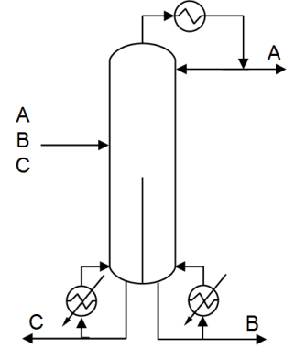
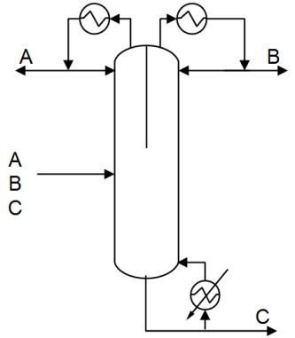
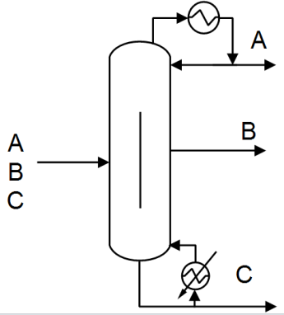

- Petlyuk-DWC (b) (c)

Figure 1: Dividing Wall Column (DWC) configurations for separating three components (A,B,C)
There are also other dividing-wall arrangements for a three-component separation, in which the partition wall is located either at the upper or at the lower part of the column shell, see Figures 1(b) and 1(c), but these require an additional condenser or reboiler. These are equivalent to a side-rectifier and a side-stripper configuration, respectively.

Another approach to make distillation more efficient and compact is to make use of liquid-liquid separation (decanting), whenever applicable. Indeed, heterogeneous azeotropic distillation is widely used in the chemical industry to separate azeotropes and close-boiling binary mixtures [1, 4]. The main idea is to “break” the binary azeotrope (A,B) by adding a third component (C), known as the entrainer [4] or solvent [1]. The entrainer (C) is generally a component that does not mix well with at least one of the components (A) in the original binary mixture, thus causing the two components (A,C) to evaporate more easily and to stay in the top part of the column, where they form an azeotrope. When condensed, the overhead vapor (close to azeotrope) forms two liquid phases which are separated in a decanter. All of the entrainer phase (C) is recycled to the column, while part of the other phase (A) is recycled (refluxed) and the remaining is taken as overhead (distillate) product. The resulting overall separation can be counterintuitive, for example, with the lightest of the original binary components ending up as the bottom product. The earliest example of heterogeneous azeotropic distillation is the breaking of the water-ethanol azeotrope using benzene as the entrainer [4]. However, azeotropic distillation arrangements are generally difficult to design and operate, because of distillation boundaries, complex thermodynamics with liquid-liquid phase split, non-linear dynamics, and the existence of multiple steady state solutions [2].

The objective of this paper is to consider heterogenous azeotropic DWC distillation applied to the separation of water (A=W) and acetic acid (B=HAC). This mixture forms a tangent pinch (“almost azetrope”) at the pure water end, where the liquid and vapor compositions are similar, making separation by conventional distillation difficult. A common industrial way of separating this mixture is to use an entrainer, for example, isobutyl acetate (C=IBA) [7].

However, in our case the original mixture actually contains a third component which can act as an entrainer (C=X). Component X is an organic component with a boiling point around 150C and with water it form a heterogeneous azeotrope with a boiling point around 98C. In addition, the feed contains small amounts of heavy organic components. In summary, we want to separate 100 kg/h of the following four-component feed mixture into pure components:

A = Water (W) Bp=100C 8.87 wt%

B = acetic acid (HAC) Bp=118C 54.55 wt%

C = organic (X) Bp=150C 35.9 wt%

D = Heavy organics (HO) Bp~200C 0.68 wt%

The heavy organics (D=HO) have almost no effect on the results in this paper. The paper is organized as follows: In Section 2 we give simulation results for the conventional configurations which is presently used in Perstorp (Figure 2). Aspen is used to simulate and optimize the process based on the data given by Perstorp. We then consider two different DWC arrangements for integrating the two distillation columns (C14 and C108 in Figure 2). First, we consider the arrangement in Figure 1b, which is quite straightforward to design and simulate (section 3).

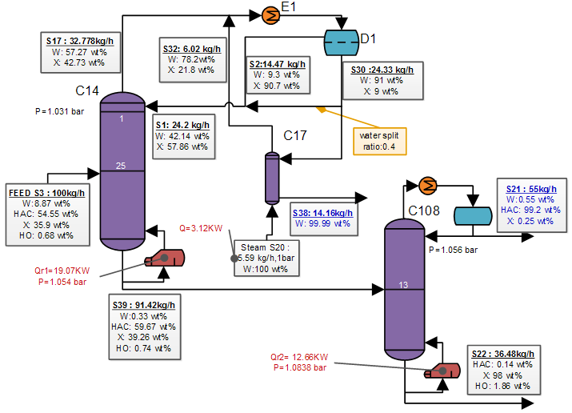
Next, we consider the Petlyuk arrangement in Figure 1a, which is much more difficult to simulate (section 4.1), and which actually cannot be applied directly to this feed mixture (section 4.2). To make it work, we need to add a new entrainer (section 4.3), and we choose to use isobutyl acetate (IBA).
Figure 2: Original design with two distillation columns (C14, C108), decanter (D1) and stripper (C17). Overall Q=34.85 kW
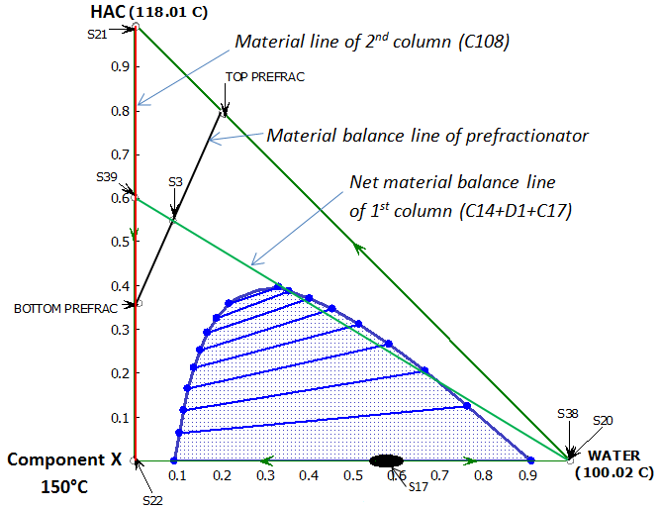

2. Conventional configuration

Figure 2 shows the flowsheet for the original conventional direct-sequence employed to separate the feed. The stream flows and the reboiler heat duties are also shown. The feed is introduced to the first column, C14. The overhead vapor of C14 (point S17 in Figure 3), which is close to the azeotrope of water and component X, is condensed and separated into two liquid phases in the decanter (D1). The organic phase, rich in X, is totally refluxed back to the top of column C14. The aqueous phase, containing mostly water, is partially refluxed, while the rest is send to the stripper column (C17) where steam (pure water) is used to strip off the remaining X which is recycled to the condenser. Almost pure water product is withdrawn at the bottom of the stripper. The bottom product of C14 goes tothe second column C108. The top product of this column is the HAC-rich product, while the bottom stream is rich in X and HO. The total energy required is 34.85KW.
Figure 3: Phase diagram for Water-HAC-X

Figure 4: Side rectifier configuration (equivalent to DWC configuration in Fig. 1b with wall in upper part of column). Overall Q=33.85 kW
3. DWC with the wall placed at the upper part of the column

We consider the simple DWC solution in Figure 1b with the partition wall placed at the upper part of the column. This arrangement eliminates one reboiler, but still needs two condensers. Assuming negligible heat transfer across the wall, this configuration is equivalent to the simulated flowsheet in Figure 4.

Some observations can be made from the simulation results. First, we cannot avoid a slippage of HAC into the bottom stream of C1 (2.89 wt% versus 0.14% in the original design). Second, this configuration consumes 33.85KW which is only slightly lower than the energy required for the conventional design. Hence, energy savings are not achieved, but the capital costs are expected to be lower.

4.DWC Petlyuk arrangement
4.1 Simulation
Next, consider the three column section arrangement in Figure 5a which is thermodynamically equivalent to the Petlyuk DWC in Figure 1a. However, the arrangement in Figure 5a has many recycles between the column sections and it is difficult to get numerical convergence when using commercial simulators (e.g. Aspen, Hysys, Unisim). Thus, for simulations we used the three-column arrangement in Figure 5b with no recycles between the columns. The heat duty removed from the condenser in C1 in Figure 5b is used to virtually superheat the top product of C1 (or equivalently, used in a side heater in C21) and the reboiler duty required in C1 is supplied from virtually subcool the bottom product of C1 (or equivalently, used in a side cooler in C22). The boilup rate in C22 is adjusted until the heat duties in the reboiler of C21 and in the condenser of C22 become equal. More details about this
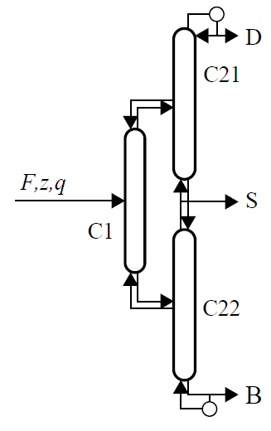
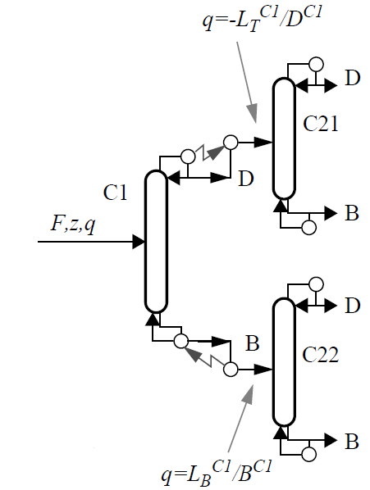
<0: superheated
>1: subcooled

(a) (b)
Figure 5: Petlyuk arrangement (a) and simulation representation (b)

approach are found in Appendix D in [6]. The configuration in Figure5(b) is equivalent to that in Figure 5(a) for optimal operation with an infinite number of stages [6], but it has been found to give almost identical results also with a finite number of stages [6].
4.2 DWC Petlyuk with original feed mixture
A direct application of the Petlyuk idea to integrate the two original columns (C14 and C108 in Figure 2) does not work. The reason is that the nonideal thermodynamics make the heavist component (X), which eventually must end up in the bottom product in C108, appear as an azeotrope with water (W) at the top part of column C14. Because of this it is not possible to get an HAC-sidestream in the Petlyuk column with no X.
4.3 DWC Petlyuk with IBA added as entrainer.
However, it is possible to operate the column system such that X does not go to the top, for example, by reducing the amount of water reflux, as we found out when simulating the original design in Figure 2. Instead, HAC g0oes to the top and since the resulting water-HAC mixture is difficult to separate, we need to add an entrainer in the top. Our first approach was to use X as the entrainer because this avoids adding a new component. We found it to be workable, but X is not an ideal entrainer because the water phase contains about 10 mol% of X (Figure 3) and simulations showed that we need quite a lot of energy to strip off X. There are many better entrainers such as isobutyl acetate (IBA), n-butyl acetate and ethyl acetate [7]. We chose IBA (Bp. 116C) which is almost immiscible with water and forms a low-boiling azeotrope at 88C (so IBA and water don’t like each oher) and forms a high-boiling azeotrope with HAC at 123C (so IBA and HAC like each other). The IBA remains in the top in a closed cycle, and only little IBA makeup is needed [7].
The simulation results are shown in Figure 6. Note that the number of trays in MAINCOL in Figure 6 is equal to the sum of stages in C21 and C22 in Figure 5b. The amount of IBA needed in the simulations was surprisingly small (only about 3 wt% IBA in the overhead vapor which is far from the azeotrope at 78 wt%). The reason is probably that only a small amount of IBA is needed to „bind“ HAC and make it less volatile. To minimize the need for IBA makeup further and make the water product purity comparable with the original design, we added a stripper (C4), similar to that in the original design, but the required amount of steam is quite small and only
contributes 0.56 kW.The total heat input for this Petlyuk arrangement is 28.12 kW, which corresponds to an energy saving of 19%, compared to the conventional design. In addition, there will be savings in the capital costs, which are probably more important. The reason for the somewhat low energy savings of 19% is partially because this is a quite easy split (with relative volatilities for W-HAC-X equal to 7.8: 2.8:1 at the feed tray of prefractionator).
Figure 6: Simulation of Petlyuk-DWC with IBA as entrainer. Overall Q=28.12 kW

5. Conclusions

This work shows applies dividing wall columns (DWC) to ternary heterogeneous azeotropic distillation. For the feed mixture of water (W), acetic acid (HAC) and an organic component (X), the original design makes use of X to act as an entrainer to facilitate the separation of water and HAC (Figure 2). We propose a DWC design based on this idea (Figure 4). This DWC design reduces the capital cost, but the energy usage is almost unchanged. To achieve energy savings and further reductions in capital costs, we need to use a Petlyuk DWC (Figures 5a and 6). However, because component X is heavier than W and HAC, X cannot be used as the entrainer for this design. Thus, we introduce isobutyl acetate (IBA) as an additional entrainer and achieve energy savings of about 20%. A challenge for discovering and designing new integrated schemes is to develop systematic methods to supplement the present ad-hoc engineering approach.

References
[1] M. Benedict and D.R. Rubin, Extractive and Azeotropic Distillation. I. Theoretical Aspects, Trans. Am. Inst. Chem. Eng., 41 (1945), 353-370
[2] S. Widagdo and W.D. Seider, Azeotropic distillation, AICE J., 42 (1996), 96-130.
[3] G.Parkinson, Dividing-wall columns find greater appeal, Chem. Eng. Prog., 103, 5 (May 2007), 8-11
[4] H.H. Pham and M.F. Doherty, Design and synthesis of heterogonous azeotropic distillations - III. Column sequences, Chem. Eng. Science, 45 (1990), 1845-1854
[5] R.O.Wright, Fractionation apparatus, US Patent No. 2471134 (1949)
[6] I.J. Halvorsen, “Minimum Energy requirements in complex distillation arrangements”, PhD thesis, Dept. of Chemical Engineering, NTNU 2001:43 (available from the home page of S. Skogestad).
[7] W.L. Luyben and I-L. Chien, “Design and Control of Distillation Systems for Separating Azeotropes “, John Willey & Sons Inc, 2010.

