Optimization of SOFC Interconnect Design Using Multiphysic Computation
Dominique Grondin,^{a,b} Jonathan Deseure,ª Mohsine Zahid,^{b} Maria José Garcia,^{b} Yann Bultelª
ªLaboratoire d’Électrochimie et de Physico-chimie des Matériaux et des Interfaces (LEPMI), UMR 5631 CNRS-INPG-UJF, ENSEEG, BP 75, 38402 Saint Martin d’Hères, France
^{b}European Institute For Energy Research (EIFER), Emmy-Noether Strasse 11, D-76131 Karlsruhe, Germany

Abstract
The aim of this work is to optimize an interconnect design. A three-dimensional model have been developed in order to investigate the effect of interconnect design on electrical performance and degradation process. Oxygen concentration, potential, current density and temperature distribution in interconnect and SOFC cathode have been calculated. Cathode degradation has been supposed to be due to temperature gradient non-uniformity. Our studies have demonstrated the impact of cathode/interconnect contact on thermal and electrical behavior. Thus, an optimization of the cathode/interconnect contact using COMSOL Multiphysics® software has been investigated. In this investigation, the effects of the two geometrical parameters are considered. This paper presents the modification of cathode/interconnect contact area and electrical collecting pins size. Simulations show a decreasing power density and a reduction of temperature gradient for an increasing contact area. With a decreasing size of collecting pins, better temperature homogeneity and power density are recorded.

Keywords: SOFC, modeling, optimization, transfer phenomena, design
  - Introduction
For the generation power, especially for stationary applications, planar SOFC stack is a promising device that converts chemical energy into electric and thermal energy using Fuel like hydrogen or methane and air in temperature ranges between 750 and 1000°C.
The serial repeating unite that forms such a stack consists of an interconnect structure and a three-layer region which is composed of two ceramic electrodes separated by a dense ceramic electrolyte. SOFC can convert hydrogen into electricity with a high efficiency (≈ 60%). Unfortunately, performance of SOFCs is strongly limited by thermal stress induced by dilatation of the ceramic layers. Since all SOFC components are solid state, in principle there are no restrictions on cell configuration. In planar configuration, interconnect plays a critical role. It is the element which ensures electrical bond between cells and supplies reactive species on the electrodes. Research efforts are mainly focused on increasing lifetime and performance. The experimental investigations have shown that interconnect decreases fuel cell electrical performance and cell durability. Several electrochemical SOFC models focus only on cathode side of fuel cell [1], because cathode activation potential is the largest source of losses in fuel cells. Oxygen-reduction reaction at cathode (Eq. (1)) plays a significant role in SOFC electrochemical behavior.
$12O_{2}+2e→O^{2−}$ (1)
Nevertheless, a multi-physic approach is required to describe cathode side. Many relevant investigations [2-4] have been carried out using three-dimensional computational fluid dynamics software. These studies consider an entire SOFC cell or a SOFC stack and emphasize the complex interactions between electrochemistry, mass and heat transfer.
  - Model development
A model of a planar half-cell SOFC was developed using the COMSOL Multiphysics® software. Electrochemical reaction within porous electrodes is described using the Butler-Volmer equation at electrode/electrolyte interface. Modeling is based on solving conservation equations of mass, momentum, energy and electric current by using a finite element approach. Simulations allow calculation of temperature, velocity, oxygen concentration, current density and potentials distributions within the cathode side (i.e. interconnect and electrode).
    - Geometry
Figure 1 shows the simulated design of current interconnect design. Air channel is formed by space between pins. Air flow inlet is in the centre. It is impossible to consider the problem using only two directions due to symmetry plan absence. Three-dimension simulations need high memory capacity. To cut down this difficulty, symmetry axes make it possible to consider only an eighth part of this configuration (Fig. 1). Regardless element sizes of this module, the porous cathode is a very thin component. Therefore, to increase chances to attain a solution and to reduce computing time, it is required to reduce the great scale difference. The thickness of the cathode has been extruded from 35µm to 1mm so as to reach the same scale order of the interconnect thickness. In this new geometrical arrangement, cathode parameters such as thermal and electric conductivities and diffusion coefficient are anisotropic in the extrusion direction. Indeed, we have multiplied by the ratio of computed thickness divided by the real one (1/0.035 ≈ 28.6) in the dilatation direction.

Figure 1: Scheme of the SOFC metallic interconnect (design of pins distribution).
    - Momentum
The mass and heat transport is done in some measure by convection route. So, velocity (u) distribution in gas channels is needed. To calculate this one, momentum equations of Navier-Stokes have been solved see Eq. (2-3). An isothermal flow and a constant air density (ρ) are assumed.
$−\vec{∇}\text{.}η\left(\vec{∇}\vec{u}+{\left(\vec{∇}\vec{u}\right)}^{T}\right)+ρ\left(\vec{u}\text{.}\vec{∇}\right)\vec{u}+\vec{∇}p=\vec{0}$ and $\vec{∇}\text{.}\vec{u}=0$ (2-3)
Where η is dynamic viscosity and p is pressure.
    - Mass
In air channels, mass transport is ensured by convection and diffusion processes. Oxygen transport in the porous cathode and along gas channels has been considered. Eq. (4) describes this phenomenon and is expressed as follows:
$\vec{∇}\text{.}\left(−D\vec{∇}c+c\vec{u}\right)=R$ (4)
D is oxygen diffusion coefficient, c is oxygen concentration and R is volume reaction rate. The electrochemical reaction occurs only at electrode/electrolyte material, thus R = 0. Inside the porous cathode, only diffusion process is solved. According to J. Deseure et al. [1], the Knudsen diffusion process is a non-negligible diffusive phenomenon in SOFC cathodes. Thus, pore walls could control the diffusion process in the cathode.
$\frac{1}{D^{\text{eff}}}=\frac{1}{D_{O_{2}}}+\frac{1}{D_{\text{knudsen}}}$ and $D_{\text{knudsen}}=d_{p}\frac{ε}{3τ}\sqrt{\frac{8\text{RT}}{{πM}_{O_{2}}}}$ (5-6)
Where, D^{eff} is effective oxygen diffusion coefficient in cathode, $D_{O_{2}}$ is oxygen diffusion coefficient in air and D_{knudsen} is oxygen Knudsen diffusion coefficient. This coefficient depends on gas temperature T, ideal gas constant R, oxygen molar mass$M_{O_{2}}$, average pore diameter d_{p}, porosity ε and tortuosity τ.
    - Charge
Electrical current continuity equation has been solved. There are no current sources in cathode and interconnect volume. Cathode and interconnect electronic conductivities are assumed to be constants. The solved equation in our problem is given by:
$\vec{J}=σ\vec{E}$ (7)
J is current density, σ is electronic conductivities and E is potential. It is assumed that most part of overpotential is located at the cathode side and the current density is given by the Butler-Volmer law [6].
    - Heat
There are three domains for heat transfer. In the first domain, transfers by conduction and radiation are modeled in interconnect and cathode. In the second domain, transfer by conduction-convection is studied in gas phase (air). Finally, in the third domain, alumina, only the transfer by conduction is solved. Constant thermal conductivities, negligible thermal resistance between cathode and interconnect and laminar flow in air channel have been assumed. In the first domain (cathode side material), the following equation is solved:
$−\vec{∇}\text{.}\left(k\vec{∇}T_{s1}\right)=Q$ (8)
T_{s1} is the solid temperature in the first domain, k is thermal conductivity and Q is volume heat source. The heat source Q involves the Joule effect. According to the conclusions of Damm et al. [7] concerning temperature distribution impact on SOFC anode supported, it should be noted that the radiative heat transfer can be neglected inside cells. Nevertheless, a radiative flux coming from the furnace of experimental device is taken into account such as a constant flux at cathode / air interface at centre inlet gas feeding (q_{inlet}). At outlet of gas channel, hydrogen and air are mixed and burnt (q_{outlet}). The resulting heat flux is scrutinized from thermodynamic data and gas flux burnt. The Newton’s law of cooling has been taken into account. In the second domain (gas phase), the non-conservative form of convection-conduction is considered. In air, there is no heat source, therefore Q = 0 and the computed equation is:
$\vec{∇}\text{.}(−k\vec{∇}T_{a}+ρ\text{Cp \{}\vec{∇}T_{a}\vec{u})=0$ (9)
Where T_{a} is air temperature, ρ is air density, Cp is air specific heat capacity. In alumina (the third domain), only the transfer by conduction is solved, ( Q = 0 ), this relation is similar to Eq. 8. Table 1 gathers main parameters values considered in simulations.

Table 1. Multi-physic Model Parameter Values
Parameter | Value | Unit | Reference
Furnace heat flux at inlet (q_{inlet}) | 8 10³ | W/m² | This study
Furnace heat flux at outlet (q_{outlet}) | 3.2 10⁴ | W/m² | This study
Ta_inlet | 1073 | K | This study
T_furnance | 1077 | K | This study
Cathode overpotential | 0.22 | V | This study
Exchange current density | 1484 | A/m² | This study
Porosity (ε) | 0.3 |  | [8]
Tortuosity (τ) | 6 |  | [8]
Average pore diameter (d_{p}) | 0.5 | µ m | [8]
Oxygen molar ratio (y₀₂) | 0.25 |  | This study
Inlet air velocity | 1.25 | m/s | This study
  - Design Optimization
In current SOFC operation and configuration, interconnect collecting pins impact on oxygen concentration and heat distribution. Indeed, our simulations show low oxygen concentration and temperature in the cathode under pins contact area (Fig. 2 and Fig. 3). Interconnect design have been modified to reduce the thermal gradient and improve electrical behaviour. The pin shape (square) is maintained. Mainly two geometric parameters are investigated. The first one was air channel width which matches a contact surface percentage. The second one was pins size.
    - Contact surface
For the current design, the contact surface is equal to 25%. It corresponds to a 2 mm air channel width. Pin size is maintained constant and contact surface varies from 12% to 60%. The smaller is the contact surface; the better is electrical performance (Fig. 4). Nevertheless, the temperature gradients increase with decreasing contact surface (Fig. 5). Pin/cathode contacts involve temperature variations: lower temperatures are recorded at pin/cathode contact.
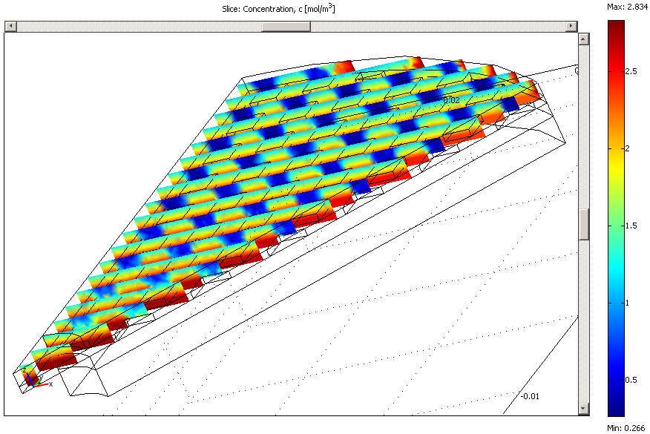  Figure 2: Simulated oxygen concentration in the cathode | 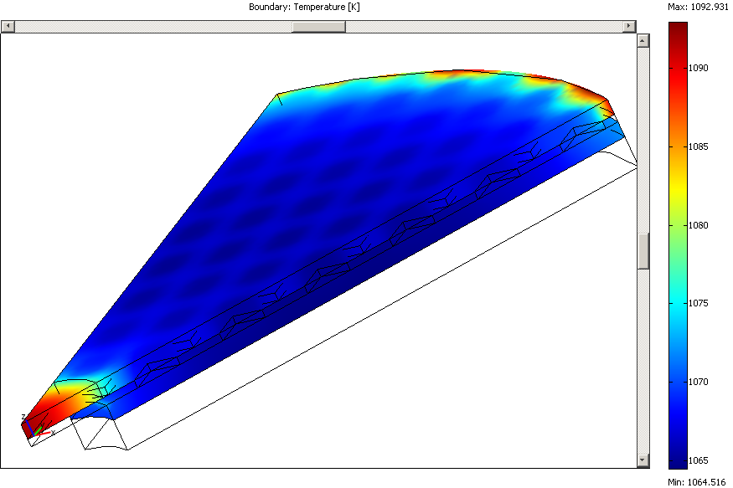  Figure 3: Simulated temperature in cathode and interconnect
Figure 4: Simulated polarization curves as function of contact surface (■: 12%, ♦: 25%, ▲: 50%, ●: 60%; — : cell potential, ---: power density) | Figure 5: Simulated temperature on cathode surface as function of contact surface (■: 12%, ♦: 25%, ▲: 50%, ●: 60%)

    - Pin size
To study pin size influence, contact surface is maintained constant and equal to 25%. For the current interconnect design, the square pin size is 2 mm. When the pin size decreases, electric performance increases (Fig. 6). It should be due to better oxygen access on reactive sites. Under pin/cathode contact diffusion process is controlled by distance of oxygen pathway. Moreover, small pins involve low temperature gradient on cathode surface (Fig. 7). Good temperature homogeneity (small-scale temperature variation) and an increasing performance using small pins (1mm) have been observed.

Figure 6: Simulated polarization curves as function of pin size (■: 1mm, ♦: 1.5mm, ▲: 2mm, ●: 2.5mm; — : cell potential, ---: power density) | Figure 7: Simulated temperature on cathode surface as a function of pin size (■: 1mm, ♦: 1.5mm, ▲: 2mm, ●: 2.5mm)

    - Selected solution
Small pins are more advantageous than larger ones. Nevertheless, at 25% contact surface, small pins involve small gas channel width. Pressure drop should be more important in this configuration. In the previous section, it has been shown an increasing surface contact implicates a decreasing electrical performance. Thus, from the interconnect design 1mm – 25%, contact surface have been diminished to improve cell behavior. The main goal of the optimization is a temperature variation below 1°C. Indeed, 16% contact surface is the best value allowing good electric performance (Fig. 9) and suitable temperature variation (Fig. 8).
Figure 8: Simulated temperature on cathode surface as a function of contact surface with 1mm pin size (■: 14%, ♦: 16%, ▲: 20%, ●: 25%) | Figure 9: Simulated power density curves with initial and optimized interconnect design (■: 25%-2mm, ▲: 16%-1mm)
  - Conclusion
A multi-physic model has been developed and solved with COMSOL Multiphysics® software. These simulations highlight controlling process and allow a good understanding of different phenomena. An optimization is proposed by varying two parameters: contact surface and pin size. The present study reveals that the interconnect design 1mm – 16% allows optimal performance. So, simulations let us expect a temperature variation two times lower and 5% gain of power density at 0.5 A/cm².

References
- J. Deseure, Y. Bultel, L. Dessemond and E. Siebert, 2005, Theoretical optimisation of a SOFC composite cathode, Electrochimica Acta, 50, 10, 2037-2046
- Jinliang Yuan, Masoud Rokni and Bengt Sundén, 2003, Three-dimensional computational analysis of gas and heat transport phenomena in ducts relevant for anode-supported solid oxide fuel cells, International Journal of Heat and Mass Transfer, 46, 5, 809-821
- B.A. Haberman and J.B. Young, 2005, Numerical investigation of the air flow through a bundle of IP-SOFC modules, International Journal of Heat and Mass Transfer, 48, 25-26, 5475-5487
- K. P. Recknagle, R. E. Williford, L. A. Chick, D. R. Rector and M. A. Khaleel , 2003, Three-dimensional thermo-fluid electrochemical modeling of planar SOFC stacks, Journal of Power Sources, 113, 1, 109-114
- P. Costamagna, A. Selimovic, M. D. Borghi, G. Agnew, 2004, Electrochemical model of the integrated planar solid oxide fuel cell (IP-SOFC),Chemical Engineering Journal, 102, 1, 61-69.
- P. Aguiar, C.S. Adjiman and N.P. Brandon, 2004, Anode-supported intermediate temperature direct internal reforming solid oxide fuel cell. I: model-based steady-state performance, Journal of Power Sources, 138, 1-2, 120-136
- David L. Damm and Andrei G. Fedorov, 2005, Radiation heat transfer in SOFC materials and components, Journal of Power Sources, 143, 1-2, 158-165

