Specialization projects (15 ECTS, but could be 7,5 ECTS) 2002 for Sigurd Skogestad
SiS1: Input and output transformation for decoupling, disturbance rejection and linearization.
Supervisor: Sigurd Skogestad
Sigurd Skogestad and Cristina Zotica have recently proposed a new idea of transformed inputs v which makes it possible to design in a simple and systematic way static control elements (blocks) that give nonlinear decoupling, nonlinear feedforward control and linearization. This work even shows when to use cascade control.
In the project work, we want to test this on a simple case study from the chemical company Perstorp. It’s a tank heated by a heat exchanger (Example 7 in the paper). We have derived some potential transformed inputs (with cascade) and the main goal of the project is to test this on dynamic simulations using Matlab.
In an extension to a Master thesis work, the goal is to propose and test further promising process examples where the method can be applied.
A link to the paper is found here:
https://folk.ntnu.no/skoge/diplom/prosjekt22/more/input_transformations_apr2022).pdf
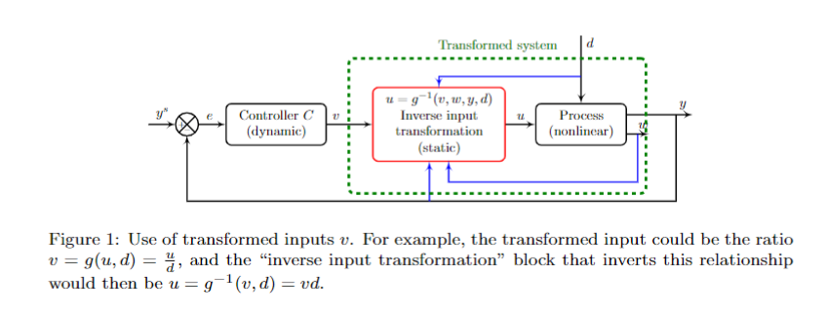
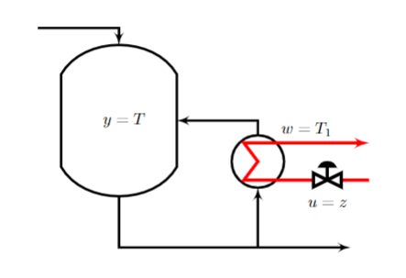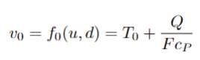
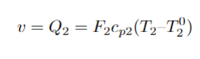

Specialization project SiS2

Applications of constrained Bayesian optimization to process systems

Supervisor: Sigurd Skogestad
Co-supervisor: Lucas Ferreira Bernardino

Keywords: machine learning, process optimization, process control
Proposal for specialization project (15 ECTS) and possible continuation for master thesis (30 ECTS).
Optimization of functions which are expensive to evaluate is a relevant limiting factor in the implementation of RTO strategies. In this context, optimization strategies that avoid direct evaluation of the objective function become appealing, and Bayesian optimization is an effective tool for that end. However, most developments have been done for unconstrained optimization problems, and there is still room for improving the available constrained Bayesian optimization procedures, which would be of most relevant to the chemical engineering applications.
The objective of this project is to study constrained Bayesian optimization algorithms, applying them to simple problems of process systems engineering. The student may begin with the use of available packages, and possibly implement custom optimization algorithms. Possible case studies include process optimization under uncertainty and the MPC tuning problem. In this sense, the work can be focused on the development of new algorithms, or on the implementation of existing algorithms in relevant engineering problems.
The student should have interest in programming. Experience with Python is an advantage.

