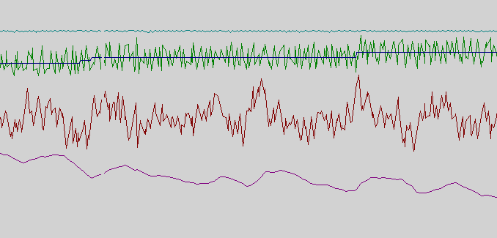
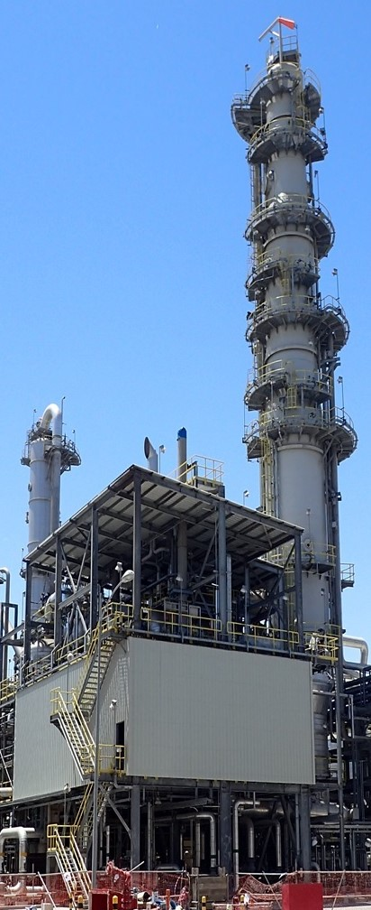

Summer Internship 2022

Are you studying process modelling and control, and eager to learn more?

We’re looking for you who is studying for a master’s degree at the department of chemical engineering at NTNU and would like to do the specialization project and the master’s thesis in collaboration with Dynea.

The project and the thesis comprise studying the dynamics of reactor temperature control for silver catalyzed formalin plants, finding promising control schemes, and optimize control performance. A dynamic model would probably be required to investigate various control approaches and can be developed in your simulation/programming software of preference.

For a complementary description of the project and the Master’s thesis proposal,
please visit Sigurd Skogestad’s website: https://folk.ntnu.no/skoge/diplom/prosjekt22/

Dynea offers a summer internship of 5 weeks for you to familiarize with the chemical process and the control philosophy, and to make relevant preparations ahead.

Qualifications:
- You are studying for a master’s degree and will graduate in 2023
- You are accurate, structured and dedicated
- You have good communication- and collaboration skills
- You enjoy modelling chemical processes and to see how they fit real world processes
- Your mindset is to strive for optimal process control without sacrificing robustness and simplicity

The location for the summer internship is our premises in Lillestrøm with start medio June.

Application letter with cover letter, CV and the latest transcript of records to be sent nilsarne.susort@dynea.com by February 27, 2022.

Any questions can be directed to:
Nils Arne Susort – nilsarne.susort@dynea.com – Mob: +47 95 86 99 44

Dynea, a Norwegian company, is a leader in developing and providing high performance adhesives, surfacing solutions and formaldehyde process technology. Offering a broad range of specialised products to customers around the world, we also provide comprehensive technical support services to ensure that our customers optimise the benefit of choosing Dynea products.

Visit our website: https://www.dynea.com/

