Reactor temperature control for silver catalyzed formalin plants

The heart of formalin production units is the reactor where methanol is partially oxidated by the presence of air to form formaldehyde. Significant amounts of hydrogen, water, CO2 + some minor side reaction products are formed as well due to the combination of dehydrogenation, partial oxidation and fully oxidation of methanol that takes place when the reaction gas is passing through the catalyst. In sum, these chemical reactions are exothermic. The reactor is adiabatic by design (apart from some insignificant heat losses to the environment), hence controlling the reaction gas composition is critical in terms of controllability, yield, availability, catalyst degradation, plant safety and more.

The reaction gas is composed mainly by the gas mixture leaving the vaporizer. Temperature, pressure and compositions in the vaporizer, as well as heat duty, circulation flow rates and other process streams in connection to the vaporizer are all variables that will affect the reaction gas composition. Furthermore, disturbances of varying intensity are always present in industrial plants, and they must be counteracted or handled in a rigorous way. In order to catch all disturbances and to get the complete picture of the reaction gas composition at any time, Dynea uses the temperature feedback from the fixed catalyst bed as the process variable. As the silver catalyzed process for producing formaldehyde is operating above the upper flammability limit (UFL) and the chemical reactions are oxidative dominant, the catalyst temperature will increase with leaner mixture and decrease if richer. The catalyst temperature measurements are highly reliable, they are producing a high process gain and they are representing very well the actual reaction gas composition or how far/close the reaction gas is towards the UFL as long as the catalyst is fully activated and dry (which is always the case except from plant start-up and shut-downs).

Despite the good properties of the catalyst temperature as a process variable for control, it is subject to lack of performance due to its feedback nature – dead-time (primarily process dead-time caused by heat and mass transport delay) and the following time constant are both limiting the control performance. Dynea uses a sophisticated control scheme to facilitate fast and safe control of the catalyst temperature which involves combining two individual PID controllers, each assigned a manipulated variable towards the process (please see the typical set-up in drawing below). However, there is room for improvement e.g. transient periods are very often challenging for the controllers. A suitable scope of a specialization project for a student would be to make a dynamic model of that part of the formalin process that is somehow influencing the catalyst temperature e.g. the process components and piping upstream the reactor. How advanced the model should be is more up to the student to decide along with the supervisor, and will depend on skill level, knowledge and timeframe. Dynea can support with relevant process data and guidance. Depending on the comprehensiveness of the model and if there is time, the student may analyze the process to find promising control schemes to improve the existing method of controlling the catalyst temperature. MPC could also be an option if desirable. Further evaluation and tuning of the selected controlling schemes would probably come later in an eventual master’s thesis, but if there is time left it could still be relevant.

An analytical approach to study the dynamics of the process could be an alternative if a dynamic model becomes too comprehensive and time consuming. The actual scope of the project must be clarified together with the student and the supervisors.

Typical set up - today

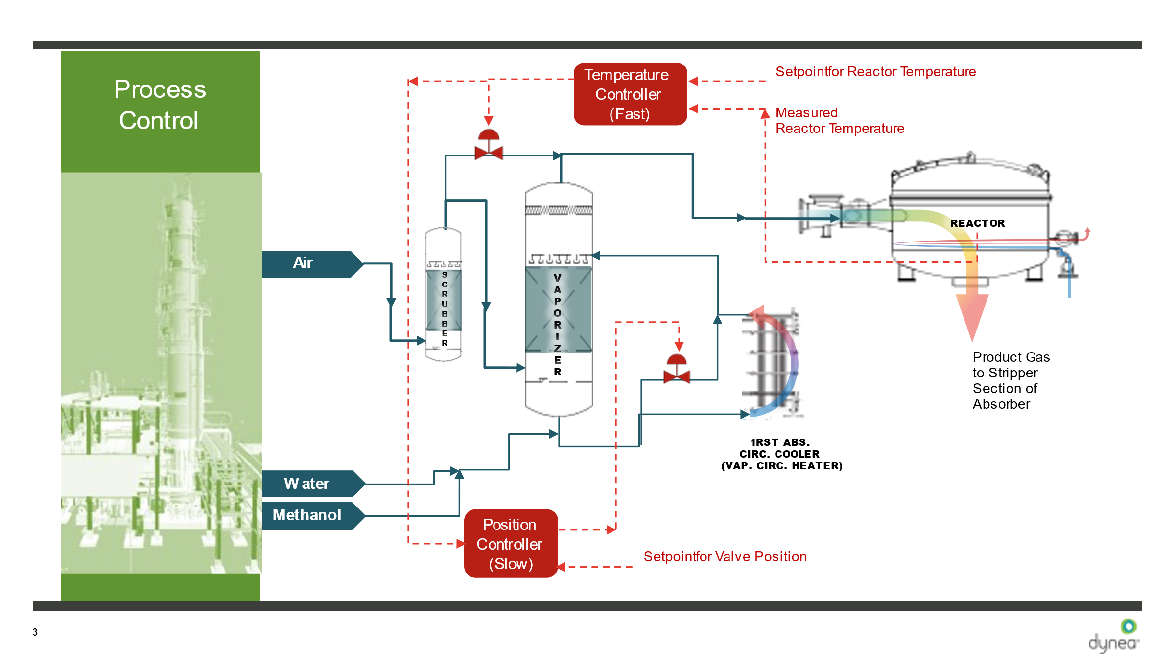

--

Discussion between Sigurd and Nils Arne about topic:

Hei Nils Arne
Det er en interessant oppgave! Jeg ser at dere har to MV og bruker «valve position control» på bypass av air.
Det er en god løsning, men jeg vet at VPC kan være vanskelig å tune og at VPC-sløyfen kan bli langsom.
Et alternativ kan være å bruke to regulatorer, en PD og en PID, som begge regulerer samme CV (temperaturen).
Et annet alternativ er MPC som du nevner.
-Hilsen Sigurd

Hei Sigurd,
Det er bra å høre at du har noen idéer.
Det vi bruker i dag er som du allerede har forstått; en TC (PI-regulator og tunet til å være rask) og en VPC (I-regulator med svært lang reset-tid).
TCen blir også overstyrt ved behov av en ekstra reguleringsfunksjon (output tracking) som har som oppgave å redusere MV når reaktortemperaturen er for mye over setpunkt og er på stigende kurs. Dette er for å «hjelpe» TC og unngå at reguleringsventilen blir forriglet i stengt posisjon eller fullstendig trip av anlegget.
Høy reaktortemperatur kan lett gjøre at anlegget går i shut-down, og det vil vi selvfølgelig helst unngå.
-Hilsen Nils Arne Susort

