Project SiS3:

Design of Control Structure for Optimal Production Operation

Supervisor: Sigurd Skogestad (Sigurd.Skogestad@ntnu.no)
Co-supervisor: Risvan Dirza (risvan.dirza@ntnu.no)

Keywords: optimization and control

Proposal for specialization project (15 ECTS) and possible continuation for master thesis (30 ECTS).
Are you reading through Master project proposals and wondering if they are what you really need when you start working in the industry?
You might already be thinking of how it would be nice to work in a project that provides you essential knowledge to get ready for the real world.
This project is perfect for you!
Goals
In this project, we will study and use PID (Proportional-Integral-Derivative) Controllers and/or Model Predictive Controllers (MPC) to design Feedback-optimizing Control (FOC) structure. Then, we will investigate the opportunity to improve it.

What is FOC?
Feedback-optimizing control is a strategy to use controllers to design the control structure that translates the economic objective into feedback control problems, thus driving the process to optimal production operation.
Why is FOC important?
One for sure in practice (industry): “everyone wants simple, cheap, and easy strategies to obtain optimal production operation”.
FOC uses what’s available on the plant: “Controllers”. Meaning: you do not need to ask for additional investment to your boss.
PID controllers is widely known by operators in the plant. MPC is widely accepted by industry. Meaning: you do not need to train your operators to operate the tools. Less training cost is required.

What We Have Now:
What we have now?
This project is part of SUBPRO project 3.9b that has been started since 2020. We have several available strategies using PIDs and/or MPC, such as
- Regional-based method,
- Primal-dual method,
- Distributed feedback-optimizing control using both primal and dual decomposition.
These methods can be implemented to various type of process system ranging form small to large-scale process systems. This is an opportunity for (a) master student(s) to learn and probably improve this work.
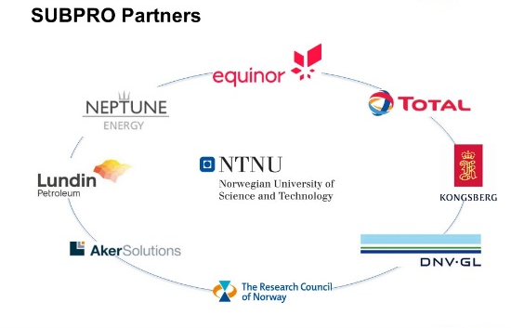

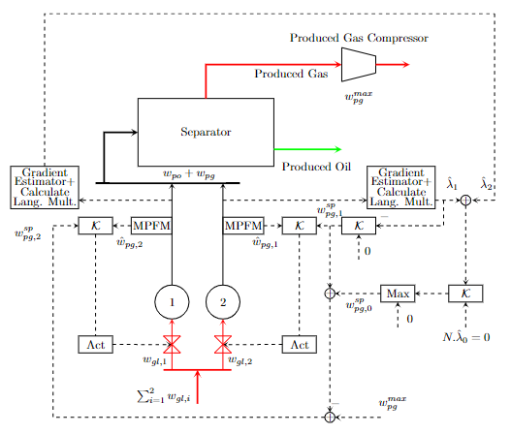 | 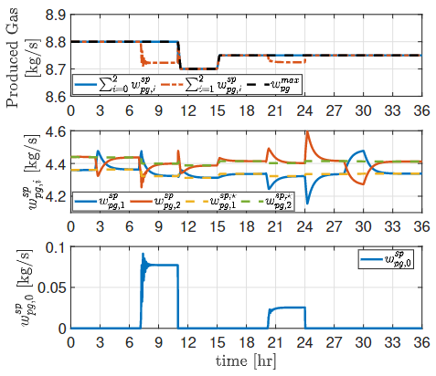
Fig. 1 Illustration of control structure constructed using the strategy of distributed feedback-optimizing control based on primal decomposition  Is FOC on applicable in oil and gas industry?  Oil and gas production and “processing system” usually consists of gas-lift wells, separator, compressor, booster pump, heat exchanger, etc., (Some models are available). However, it does not mean that the knowledge you earn is restricted to oil and gas. Some of the processing system in oil and gas facility is also applicable to many industries, and therefore the case study can be modified as necessary. Don’t worry, we can discuss it! | Fig. 2 Simulation results of control structure constructed using the strategy of distributed feedback-optimizing control based on primal decomposition

What are we looking for in candidates?
We mostly enjoy working and learning together with student who has interest in control, optimization, and be familiar with programming.
What are you going to do?
- Discuss, study, and construct (if necessary) the model of the case study you are interested in.
- Study, extend (if necessary), and simulate the simplified model of the case study using MATLAB or Python
You can choose the programming language!
- Implement, compare, and probably improve FOC strategies. If you are interested, we can improve the strategies, i.e., modifying control structure or incorporating machine learning tools.
- Analyze the pro and cons of the strategies.

Any question?
Need preliminary materials?
Feel free to contact Professor Sigurd Skogestad (Sigurd.Skogestad@ntnu.no) or PhD Candidate Risvan Dirza (risvan.dirza@ntnu.no).

Project SiS4:

Experimental Validation of Control Structure for Optimal Production Operation

Supervisor: Sigurd Skogestad (Sigurd.Skogestad@ntnu.no)
Co-supervisor: Risvan Dirza (risvan.dirza@ntnu.no)

Keywords: optimization, control, and experimental work

Are you reading through Master project proposals and worried that most of them seem purely theoretical?
Let’s try experimental work!
Goals
In this project, we will experimentally validate various Feedback-optimizing Control (FOC) structure strategies in a small lab rig.

Proposal for specialization project (15 ECTS) and possible continuation for master thesis (30 ECTS).
Motivation:

What is FOC?
Feedback-optimizing control is a strategy to use controllers to design the control structure that translates the economic objective into feedback control problems, thus driving the process to optimal production operation.
Why is FOC important?
One for sure in practice (industry): “everyone wants simple, cheap, and easy strategies to obtain optimal production operation”.
FOC uses what’s available on the plant: “Controllers”. Meaning: you do not need to ask for additional investment to your boss.
PID controllers is widely known by operators in the plant. MPC is widely accepted by industry. Meaning: you do not need to train your operators to operate the tools. Less training cost is required.

What we have now?
This project is part of SUBPRO project 3.9b that has been started since 2020. We have several available strategies using PIDs such as
- Regional-based method,
- Primal-dual method,
- Distributed feedback-optimizing control using both primal and dual decomposition.
We have validated a method in the experimental lab rig. It means the set up for validation work is available.
Therefore, you will have the opportunity to learn the set up and validate more strategies, and most importantly “have hands-on experience” to implement, observe and analyze the practical implementation of the strategies. We will run experiments in the lab rig.!!

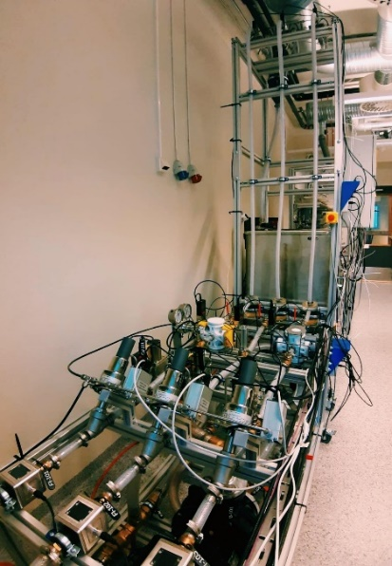 | 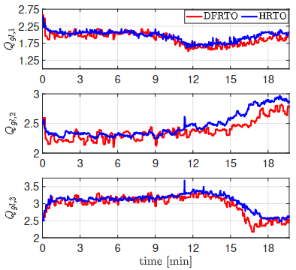
Fig. 1 The experimental lab rig  The experimental lab  Our experimental lab rig emulates a gas-lift oil production system. The optimization objective is to maximize the oil production while minimizing the consumption of the gas lift | Fig. 2 Experimental results of control structure constructed using the strategy of distributed feedback-optimizing control based on dual decomposition
What are we looking for in candidates?
We mostly enjoy working and learning together with student who has interest in control, optimization, and be familiar with programming.

What are you going to do?
- Discuss, and study the available strategies
- Study and implement the available strategies on the simplified model using MATLAB.
- Study and get familiar with Lab’s code and interface (MATLAB and LabVIEW)
- Experimentally validating the strategies in the lab rig.
- Analyze the pro and cons of the strategies based on experimental results.

Any question?
Need preliminary materials?
Feel free to contact Professor Sigurd Skogestad (Sigurd.Skogestad@ntnu.no) or PhD Candidate Risvan Dirza (risvan.dirza@ntnu.no).

