SiS1. Optimal operation of energy storage systems

Supervisor: Sigurd Skogestad (Sigurd.Skogestad@ntnu.no)
Co-supervisor: David Pérez Piñeiro (david.p.pineiro@ntnu.no)

Proposal for specialization project (15 ECTS) and possible continuation for master thesis (30 ECTS).
With the integration of more renewables into the electric grid, the use of energy storage systems is becoming increasingly important to manage these intermittent sources of energy. Let’s consider, for example, the energy system shown in Figure 1, where the time-varying energy demand from a building must be satisfied by combining energy from a wind farm (time-varying, but free supply), a battery, and/or the power grid (unlimited supply, but time-varying prices). The objective is to design a controller to operates the system such that the energy demand from the building is satisfied with minimum cost over time.

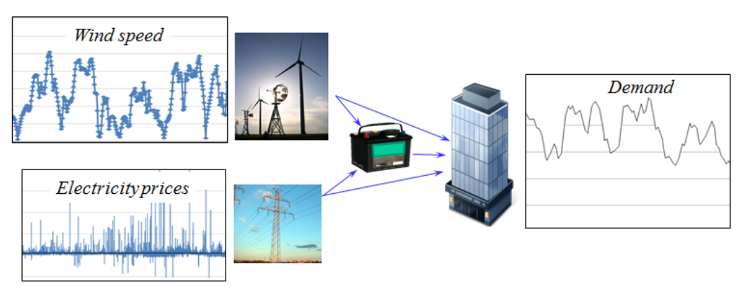
Figure 1 Energy system consisting of wind farm, power grid, battery storage, and a building.
To accomplish this goal, the student will:
- Model the system and formulate an optimal control problem.
- Design a data-based economic model predictive controller using reinforcement learning to learn the optimal policy based on real-time operating data (find a reference to a relevant paper below).
The student should have an interest in optimization and control, and experience with programming (Matlab, Julia, or Python). Courses TKP4140 Process Control and TTK4135 Optimization and control, and experience with dynamic simulations and optimization are an advantage.

  - References
Gros, S., & Zanon, M. (2019). Data-driven economic NMPC using reinforcement learning. IEEE Transactions on Automatic Control, 65(2), 636-648. URL: https://ieeexplore.ieee.org/document/8701462

SiS2. Modeling and Optimal Operation of Field-wide Gas-lifted Oil Well Production Network

Supervisor: Sigurd Skogestad (Sigurd.Skogestad@ntnu.no)
Co-supervisor: Risvan Dirza (risvan.dirza@ntnu.no)

Keywords: optimization, modeling, oil and gas

Proposal for specialization project (15 ECTS) and possible continuation for master thesis (30 ECTS).
Oil production systems consists of many interconnected subsystems and processes such as compressor, booster pump, scrubber, and separators. Model that represents a complete production facility is essential for production optimization. The main task of this project is to integrate and develop a model of required production facility for production optimization.

Possible tasks of this project are:
- Study and improve gas lifted well model up to riser.
- Develop simplified model for separators, compressors, (multiphase) booster pump etc., and simulation using MATLAB\Python.
- Implement production optimization
  - Using numerical solver
  - Using systematic approach

This project is part of SUBPRO. The student should have an interest in oil and gas operation, optimization, and control. TKP4140 Process Control and experience with dynamic simulations are an advantage.

SiS3. Hybrid modeling of separation processes using machine learning

Supervisor: Sigurd Skogestad
Co-supervisor: Lucas Ferreira Bernardino

Keywords: machine learning, process modeling, nonlinear systems
Proposal for specialization project (15 ECTS) and possible continuation for master thesis (30 ECTS).
Machine learning techniques are powerful tools for the efficient use of system data for the development of models, which can in turn be applied in process control and optimization. In this context, the level of detail of the models plays a key role in the successfulness of their applications, and simple models can often be generated with some insight of the relevant variables of the system.
The objective of this project is to generate hybrid model structures, in which some of the variables are modelled using machine learning and apply these models in standard optimization and control problems. Some possible case studies to this project are CO₂ capture systems and distillation columns, for which experimental data is available.
The specific tasks for this project are:
- Train machine learning models to correlate the relevant process variables in the case study.
- Implement a steady-state model to perform design and optimization of the case study.
- Implement a dynamic model to perform predictive control of the case study.
The student should have interest in programming. Experience with MATLAB/Python and model simulations are an advantage

