Project SiS1. Optimal operation and control of flexible heat-to-power cycles

Supervisor: Sigurd Skogestad (Sigurd.Skogestad@ntnu.no)
Co-supervisor: Cristina Zotica (cristina.f.zotica@ntnu.no)

Keywords: process control, optimal operation, steam cycles, intermittent heat, energy storage

Proposal for specialization project (15 ECTS) and possible continuation for master thesis (30 ECTS).
The objective is to identify optimal operation and control of a heat-to-power cycle with varying heat source. Consider a typical heat-to-power cycle, as shown in Figure 1. In this process, thermal energy from the heat source (hot flue gas) is converted to mechanical energy, which in turn is converted to electrical energy in the generator. The working fluid is heated from liquid water (blue) to high-pressure superheated steam (red) by exchanging heat with flue gas (black) in a series of heat exchangers for each operating regime. The high-pressure superheated steam is expanded to low-pressure saturated steam in a turbine which drives a generator (G) to produce electric power for the electric grid. The low-pressure steam is condensed with cooling water (CW) in the condenser to liquid water, which is then boosted by a variable speed pump, and is fed to the drum.
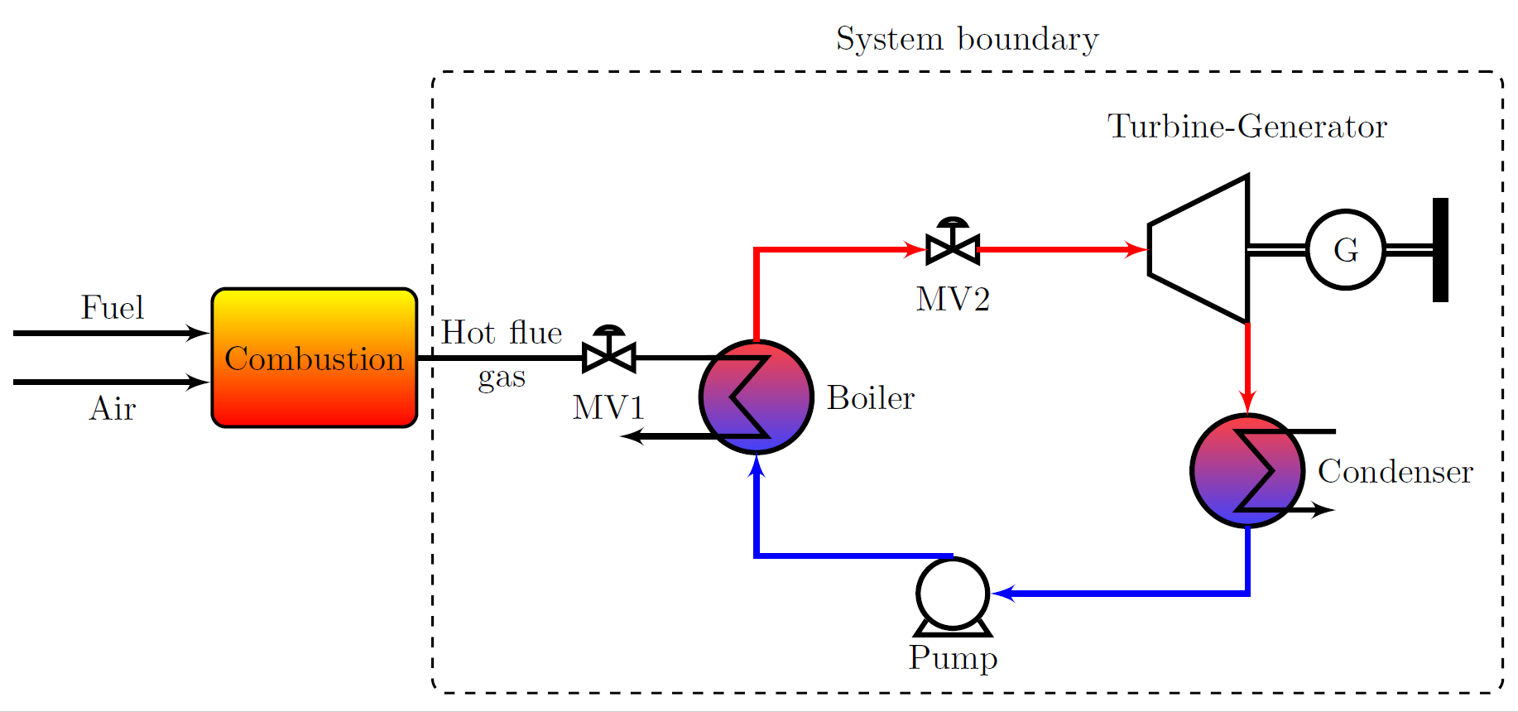
Figure 1 Simplified heat-to-power cycle flowsheet. The dotted line shows the boundary of the system (steam side).
The tasks for this project are to analyze:
- To which extend and on which time scale the energy stored in the system’s liquid holdup and walls can used.
- The effect of a steam accumulator to store high pressure steam and balance power demand and supply.
The student should have an interest in operation and control. TKP4140 Process Control and experience with dynamic simulations are an advantage.

Project SiS2. Coordination of generation and demand in steam networks

Supervisor: Sigurd Skogestad (Sigurd.Skogestad@ntnu.no)
Co-supervisor: Cristina Zotica (cristina.f.zotica@ntnu.no)

Keywords: optimal operation, control, coupled systems, steam generation, distribution network

Proposal for specialization project (15 ECTS) and possible continuation for master thesis (30 ECTS).
Steam generation and distribution network play an extensive role in the chemistry industry, and there is much to gain from optimizing their operation and increase the plant energy efficiency.
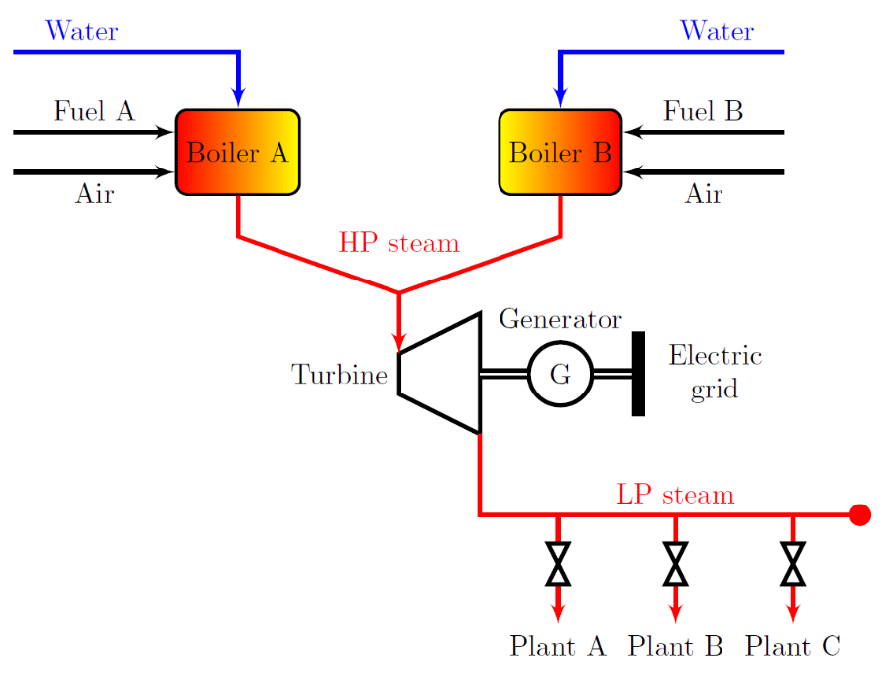
The objective is to implements simple control policies that coordinate the generation and demand in a steam distribution network.
Figure 1 Process flowsheet of boilers and steam network
Figure 1 shows a simplified flowsheet of the system. Here, two boilers generate high pressure steam by burning different fuels, Fuel A and Fuel B respectively. The high pressure (HP) steam is expanded to low pressure (LP) in a turbine which drives a generator to produce electric power to the grid. The low pressure steam is distributed through a steam network to each consumer (Plant A, B,C).

The tasks of this project are:
- Develop an existing dynamic model of a steam cycle by adding the steam distribution network and consumers plants. The model will be based on mass and energy balance.
- Perform dynamic simulations (using Matlab/Simulink).
- Identify manipulated variables, controlled variables, main disturbances and operational constraints.
- Based on step 3, implement a simple control structure to coordinate the steam generation in the boilers with the steam demand. Structures to be considered are advanced control structures: split range control, selectors, controllers with different set-point or parallel control (where one controller has integral action and the rest have only proportional action).
The work can be extended into a master thesis by comparing the simple control structures with a centralized controller (model predictive control). The student should have an interest in operation and control. Courses TKP4140 Process Control and TTK4135 Optimization and control, and experience with dynamic simulations are an advantage.

Project SiS3. Control structures with embedded process knowledge

Supervisor: Sigurd Skogestad (Sigurd.Skogestad@ntnu.no)
Co-supervisor: Cristina Zotica (cristina.f.zotica@ntnu.no)

Keywords: linearization, decentralized control, decoupling, process control,
disturbance rejection

Proposal for specialization project (15 ECTS) and possible continuation for master thesis (30 ECTS).
This project will build on work currently developed in the group.
The objective is to find new transformed manipulated variables (MVs) for nonlinear systems which linearizes and decouples the system, and gives perfect feedforward control for disturbances (at least at steady-state). We may also introduce an output transformation from the measurement y to chosen states x, for some chemical processes where the nonlinearities arise from state-measurement relationship, e.g. pH, or density measurement.
The proposed new input and output transformation allow for multiple-inputs multiple-outputs (MIMO) systems, disturbances, a more general class of models. The key idea is to use decentralized SISO controllers for the state x using the new transformed inputs v as MVs. The SISO controllers give v, and a nonlinear calculation block solves algebraic equations which explicitly gives the original input u as a function of the controller output v, state x and disturbances d. A second nonlinear calculation block solves algebraic equations that give the states x as a function of measurements y. The input calculation block also handles the decoupling, and feedforward action from the disturbance d.
This new procedure can be applied both for static and dynamic process, which is typical in process control. The block diagram is shown in Fig.1.
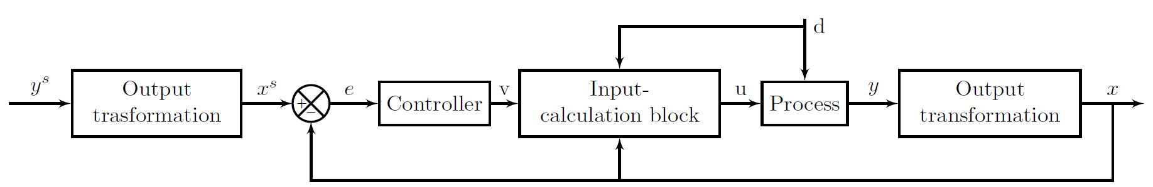
Figure 1 Block diagram of a control structure with embedded process knowledge through input and output transformation.
Variable definition
u-physical input (MV); v-transformed input; x-state; y-measurement; d-disturbance
This method is similar to feedback linearization, which implies transforming a nonlinear system into a linear system by changing the inputs or outputs. The difference is that we consider a system with equal inputs (u) and output (y), we include systems nonlinear in the inputs (u), and we also measure the disturbance (d).

Project SiS4. Systematic design of advanced control structures

Supervisor: Sigurd Skogestad (Sigurd.Skogestad@ntnu.no)
Co-supervisor: Cristina Zotica (cristina.f.zotica@ntnu.no)

Keywords: process control, split range control, valve position control, selectors, constraints

Proposal for specialization project (15 ECTS) and possible continuation for master thesis (30 ECTS).
The majority of controllers in the chemical industry are PID controllers. However, design of industrial control structures is based on previous experience, and a systematic design procedure is missing.
The objective is to implement optimal operation efficiently, especially when there are changes in active constraints. This is a really interesting project where we expect to find new publishable results with a high impact for industry. Structures to be considered include split range control, input (valve) position control, controllers with different setpoints, selectors, cascade, feedforward and physical decouplers.
The student should have an interest in operation and control. TKP4140 Process Control and experience with dynamic simulations are an advantage.

  - References
Reyes-Lúa, A., Skogestad S., 2019. Systematic Design of Active Constraint Switching Using Classical Advanced Control Structures. Industrial & Engineering Chemistry Research 2020 59 (6), 2229-2241 DOI: 10.1021/acs.iecr.9b04511, URL: https://doi.org/10.1021/acs.iecr.9b04511

Project SiS5. Design of Computational Experiments for Machine Learning

Supervisor: Sigurd Skogestad (sigurd.skogestad@ntnu.no)
Co-supervisor: Allyne dos Santos (allyne.dos.santos@ntnu.no)

Keywords: experiment design, machine learning, neural networks, timeseries, dynamic systems, gradient estimation

Proposal for specialization project (15 ECTS) and possible continuation for master thesis (30 ECTS).
Consider a case when the first-principle model is available, but it is complex, and time consuming to simulate and optimize it. Therefore, a model that is faster and simpler is necessary. For the model to be able to reproduce the gradient behavior of a nonlinear process, the system needs to have a certain level of excitation. Design of experiments is a way to simulate the system capturing all nonlinear behavior reducing the number of experiments as much as possible.
The objective is to implement two types of design of computational experiments, Latin Hypercube Design (LHD) and Multilevel Binary Replacement (MBR), use it to train an Echo-State Network and predict the gradient of the system.
The tasks of this project are:
- Develop a routine to implement both methods of design of computational experiments.
- Identify candidates to be disturbance, manipulated and controlled variables.
- Perform simulations to acquire data of an Oil Well Network problem (using python/Matlab).
- Predict output data (the gradient) using Echo-State Network (ESN).
The project can be extended into a master thesis by applying the ESN model into a supervisory control. The student should have an interest in programming. TTK4135 Optimization and control and experience with dynamic simulations are an advantage.

Project SiS6. Application of Spiking Neural Networks in Process Control

Supervisor: Sigurd Skogestad (sigurd.skogestad@ntnu.no)
Co-supervisor: Allyne dos Santos (allyne.dos.santos@ntnu.no)

Keywords: machine learning, static systems, neural networks, process control

Proposal for specialization project (15 ECTS) and possible continuation for master thesis (30 ECTS).
Consider a case when the first-principle model is available, but not all variables that are needed to calculate the gradient are available. Therefore, the optimal condition is not available. The objective is to train a Spiking Neural Network (SNN) to predict the gradient with the available measurements for a controller to actuate on the system so it reaches the optimal condition.
The tasks for this project are:
- Model a Heat Exchanger Network problem.
- Identify candidates to be disturbance, manipulated and controlled variables.
- Perform simulations using a design of computational experiments.
- Apply supervised learning technique in python (or Matlab, alternatively) using SNN.
The project can be extended into a master thesis by applying the SNN model into a supervisory control. The student should have an interest in programming. Courses TKP4140 Process Control and TTK4135 Optimization and control and experience with python/Matlab are an advantage.

Project SiS7. Transfer learning applied to oil wells with anti-slug control

Supervisor: Sigurd Skogestad
Co-supervisor: Lucas Ferreira Bernardino

Keywords: machine learning, neural networks, process control and optimization, nonlinear systems

Proposal for specialization project (15 ECTS) and possible continuation for master thesis (30 ECTS).

Machine learning techniques are powerful tools for the efficient use of system data aiming for its modeling, which can be used for process control and optimization. In this context, transfer learning aims to use knowledge about similar systems, for which information is more abundant, to better predictions.

The objective is to generate machine learning models based in expert knowledge on oil wells with anti-slug control (e.g. in the form of a first-principle model) and apply transfer learning techniques to use this model on experimental data from a pilot oil well.

The specific tasks for this project are:
- Train neural network models based on the first-principle model of the oil well;
- Implement the base case for transfer learning from the model to the available experimental data;
- Investigate the conditions for the transfer learning (which weights must be updated, how to tune the regularization, etc.)

It is desired that the student has interest in programming. Experience with MATLAB/Python and model simulations are an advantage.

Project SiS8. Reinforcement Q-Learning for Model Free Optimal Control

Supervisor: Sigurd Skogestad (Sigurd.Skogestad@ntnu.no)
Co-supervisor: Saket Adhau (saket.adhau@ntnu.no)

Keywords: process control, optimal operations, machine learning, reinforcement learning
Proposal for specialization project (15 ECTS) and possible continuation for master thesis (30 ECTS).
Reinforcement Learning (RL) is a fast-developing field of research, which explores the available data to improve decision-making for dynamic as well as steady state systems. The main task is to implement the existing Q-learning algorithms, policy iteration (PI) and value iteration (VI) for process control to significantly improve the decision making time and possibly to reduce the computational burden.
The idea is to maximize the heat recovery in a heat exchanger network connected to a set of batch reactors or any other suitable nonlinear process model.

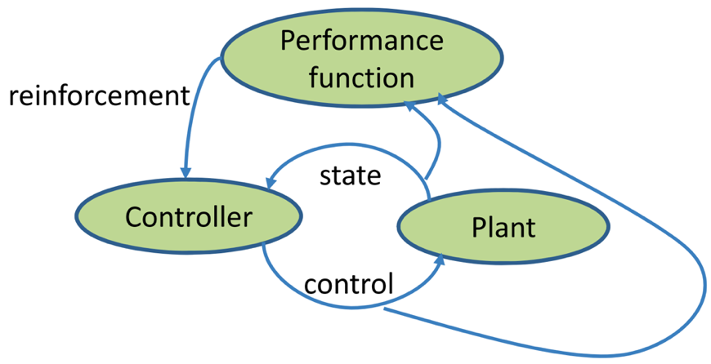
The expected tasks of this project are:
- Implement and test Q-learning in MATLAB or Python for heat exchanger or similar complex model.
- Verify if the safety constraints are followed and suggest a method to learn the policy accordingly.
- Investigate the tuning parameters in order to improve the learning.

The project can be extended into a master thesis by applying safe learning policies for the same with certification to the solution obtained from the Q-Learning. The student should have an interest in TTK4135 Optimization and control and experience with programming in Matlab/Python are an advantage.

Reference:
Zanon, Mario, and Sébastien Gros. "Safe Reinforcement Learning Using Robust MPC." arXiv preprint arXiv:1906.04005(2019).
Project SiS9. Using Transfer Learning to reduce the training efforts in event of an objective function change

Supervisor: Sigurd Skogestad (Sigurd.Skogestad@ntnu.no)
Co-supervisor: Saket Adhau (saket.adhau@ntnu.no)

Keywords: process control, optimal operations, machine learning, reinforcement learning

Proposal for specialization project (15 ECTS) and possible continuation for master thesis (30 ECTS).

We consider a constrained nonlinear optimization problem and assume we have all the input-output pair which can solve a given objective ($J1$). A simple neural network is trained to learn the policy for the objective ($J1$). The task is to use the pre-trained neural network and learn the new policy for the objective ($J2$) without the need to retrain the new network from scratch. The new objective function ($J2$) would have some similar parameters with a minor change in the objective function.

The project would include:
- Train a basic input output neural network for a given process model to learn a policy for objective ($J1$).
- Change the trained neural network to learn the new policy for a new objective ($J2$) without the need to retrain it from scratch.
- Investigate the feasibility of the new learned policy and the identify parameters to consider while training and re-training of the network.

The student should have an interest in TTK4135 Optimization and control and experience with programming in Matlab/Python are an advantage.

  - References
Vallon, Charlott, and Francesco Borrelli. "Task Decomposition for Iterative Learning Model Predictive Control." arXiv preprint arXiv:1903.07003 (2019).

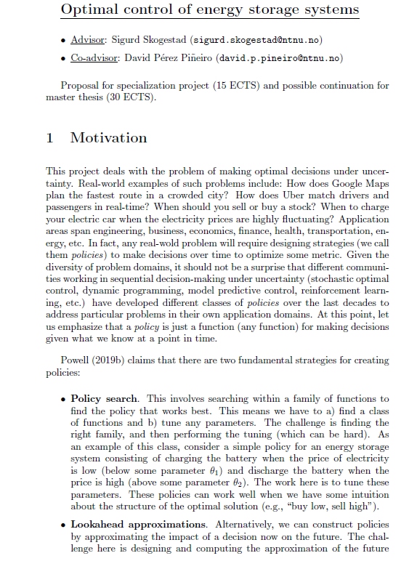
Project SiS10

