Prosjektoppgaver2016 for Sigurd Skogestad

Modelling, optimization and control of subsea separation
Co-supervisor: Christoph Backi
This project is part of the SUBPRO project which is a new large research project in cooperation with Statoil, Shell, Engie, Lundin, Aker Solution, ABB and DNV GL.
The separation involves gas-liquid or liquid-liquid separation using gravity separators, cyclones or flotation units. The model may be in Matlab, Hysys or Modellica.

Investigation of surrogate models with the Ammonia synthesis loop as case study.
Main supervisor: Sigurd Skogestad
Co Supervisor: Julian Straus
Optimal operation of existing plants is generally needed in highly competitive markets like the ammonia industry. This leads to highly integrated energy and material streams within the process. Most processes are modeled using a sequential-modular approach, in which unit operations (UO) are solved sequentially. Due to the integrated nature of the processes, solving a flowsheet can take long. In addition, flowsheet simulators are designed as black-box models which are not allowing the optimizer algorithm to access the underlying equations. As a result, optimal conditions are difficult to obtain.
Our idea to circumvent this problem is the introduction of surrogate models, which can be seen as defined auxiliary models mapping the process. The advantage is given by simplification and access to the mathematical foundation of the model. In addition, variable transformation and application of process knowledge can be utilized in defining the surrogate model. The core of the project is hence given by:
- Analysis of state-of-the-art approaches for steady-state optimization.
- Definition and design of the surrogate model.
- Implementation of a MATLAB/HYSYS interaction and analysis of the Model behavior.
- Definition of challenges and opportunities for future research.
This project requires basic knowledge in Aspen HYSYS and in optimization (TTK4135 Optimization and Control recommended, but not required. Advanced knowledge in MATLAB is additionally required.
The complete steady state model of the synthesis loop is already existing in HYSYS and will be used as starting point. This project is part of an industrial cooperation with Yara.
If questions arise and/or you are interested in the project, feel free to contact Julian Straus (julian.straus@ntnu.no, or pass by in room K4-239).
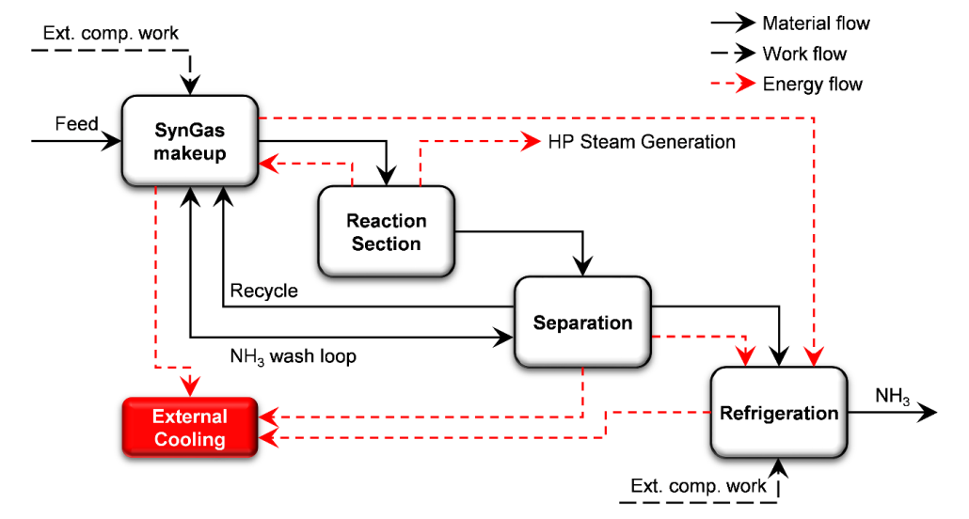

Title: Optimal operation of small LNG refrigeration cycles
Supervisor: Sigurd Skogestad (skoge@ntnu.no)
Co-supervisor: Adriana Reyes (adriana.r.lua@ntnu.no)
Description:
Small-scale LNG plants have been installed recently on LNG carriers to re-liquefy BOG, reducing product loss and minimizing flaring. The optimum operating conditions are determined by conditions that are not practical to be measured continuously in a carrier.
This situation is an excellent example to explore the convenience of using self-optimizing control variables (Skogestad 2000, 2004). In this procedure the identification of the steady-state degrees of freedom and the definition of the throughput manipulator (TPM) are important steps. Identifying the DOF for optimal operation is not always straightforward, partly because not all the physical DOF (“valves”) are used in the same way. Refrigeration processes are commonly closed systems and this brings additional challenges (Aske & Skogestad, 2009; Jensen & Skogestad, 2009).
The work proposed for this master thesis is to optimize the plant described by (Nekså et al. 2010).The student will use and probably improve a Matlab model that was developed previously. An important part of the analysis will be to evaluate different control structures and identify the advantages and disadvantages of using the physical degrees of freedom in the mini LNG refrigeration cycle in different ways and possibly to investigate the dynamic effects of the positioning of the TPM.
The student should have knowledge of optimization (QP, NLP). He/she should have experience using Matlab and preferably process simulators (e.g. HYSYS). Please contact Adriana Reyes (adriana.r.lua@ntnu.no) for further information.
References:
Aske, E. M. B., & Skogestad, S. (2009). Consistent Inventory Control. Industrial & Engineering Chemistry Research, 48(24), 10892–10902. doi:10.1021/ie801603j
Jensen, J. B., & Skogestad, S. (2009). Steady-State Operational Degrees of Freedom with Application to Refrigeration Cycles. Industrial & Engineering Chemistry Research, 48(14), 6652–6659. doi:10.1021/ie800565z
Nekså, P., E. Brendeng, M. Drescher, and B. Norberg. 2010. “Development and Analysis of a Natural Gas Reliquefaction Plant for Small Gas Carriers.” Journal of Natural Gas Science and Engineering 2(2-3): 143–49. http://www.sciencedirect.com/science/article/pii/S1875510010000326 (January 20, 2015).
Skogestad, Sigurd. (2000). “Plantwide Control: The Search for the Self-Optimizing Control Structure.” Journal of Process Control 10(5): 487–507. http://dx.doi.org/10.1016/S0959-1524(00)00023-8 (December 3, 2013).
Skogestad, S. (2004). Control structure design for complete chemical plants. Computers & Chemical Engineering, 28(1-2), 219–234. doi:10.1016/j.compchemeng.2003.08.002
Title: Dynamisk regulering av anlegg for produksjon av flytende hydrogen
Mye av vinden som blåser over Varangerhalvøya kan konverteres til elkraft, men det finnes ikke kapasitet i nettet for å eksportere kraften. Derimot har japansk industri vist interesse for å benytte denne strandede vindenergien til storskala hydrogenproduksjon og –eksport til Japan (gjerne via nordøstpassasjen).
Hydrogen genereres av strøm og vann via elektrolyse, og så gjøres flytende for transport i store tankskip. Disse er i dag fortsatt ved konseptstadiet, men store industrikonsern som Kawasaki har vist interesse i idéen.
Det ble nylig utviklet avanserte løsninger for anlegg for produksjon av flytende hydrogen, mest relevant i EU-prosjektet IdealHy, som vil være startpunkt for oppgaven. SINTEF deltok i prosjektet med partnere som Shell, Linde, TU Dresden og Kawasaki, og kan gi tilgang til data, modeller og kontaktnettverk.
Det er en kjent problematikk innad IdealHy at prosessen de utviklet er riktignok mye bedre enn tidligere metoder, men krever stasjonære betingelser. Dette er ikke realistisk i forbindelse med store vindparker, da deres effektproduksjon vil variere sterkt fra time til time, med kort eller ingen varsel i endringer.
Oppgaven går altså ut på å:
• Modellere et stort anlegg for hydrogenproduksjon, flytendegjøring og eksport, med basis i IdealHy;
o Programmeringsspråk kan være Python, Modelica, Matlab eller hva kandidaten er best i.
• Gjøre de nødvendige endringer i modellen for å gjøre den dynamisk;
• Evaluere anleggets dynamiske egenskaper, spesielt med hensyn på raskt varierende tilgang på kraft;
• Definere en reguleringsstrategi som muliggjør dynamisk drift av anlegget, herunder anleggsmodifikasjoner som bufferenheter, valg av egnede enhetstyper (f.eks. PEM vs. alkaliske elektrolysører), systemredundans / pålitelighet;
• Ta hensyn til sammenhengen i Varangerhalvøya: mulighet til å benytte lokal vannkraft for lagring, begrensninger på eksport, mm.

Oppgaven kan gjerne fokuseres på noen spesifikke områder etter kandidatens ønske (i samråd med veiledere).

Krav: interesse for og kompetanse i dynamisk modellering / simulering, samt relevant erfaring i programmeringsspråk (hvilke er ikke så viktig, men Modelica er nok en fordel). Gode kunnskaper i engelsk da mye av dokumentasjonen er fra internasjonale prosjekter.
Faglærer: Sigurd Skogestad
Medveiledere: Steffen Møller-Holst, Markedsdirektør for hydrogen i SINTEF; Federico Zenith, seniorforsker i SINTEF.
Title: Identification of the correct model structure of linear multivariable systems
A dynamic model is often based on experimental data for the inputs (u) and outputs (y). However, when the model is used for control, the objective is not necessarily to get the best fit, but the model that is best for control. There exists standard tools for model identification in Matlab, but although the mathematical theory may be strong, the assumptions often make them less useful.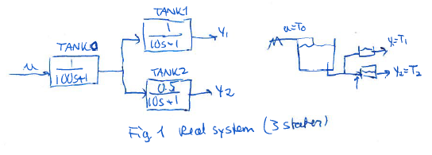
As an example, we will consider a real system with 3 physical dynamic states, see Figure 1. This represents the temperature response of a system with 3 tanks, where the first shared tank has a residence time of 100s and the last two tanks have a residence time of 10 s each. Here u= T0 is the inlet temperature (which we assume can be manipulated by a heater) and y1 and y2 are outlet temperatures. The reason for one of the gain being less than 1 in tank 1 is that the flow to thank 2 is mixed with an equal amount of another stream.
The objective is to use data for u(t) and y(t) to identify the dynamic model. To generate the data for y(t), we may make a step in u. We assume there is noise on y1 and y2, and there may also be disturbances at various locations.
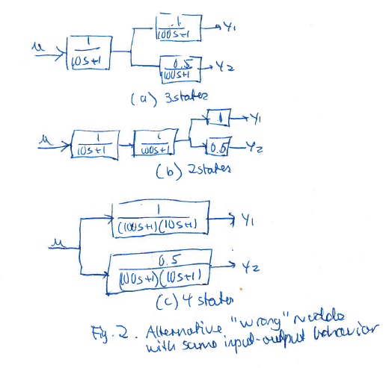

However, if we apply standard system identification we may instead get one of the models in Fig. 2. They have the same input-output response as the real system, but for control purposes, they will not be correct. To understand this, assume that we add a feedback controller and use u to control y2 (e.g., a P-controller u = Kc (y2s-y2) with Kc=20). The resulting response from ys2 to y2 will then be very different for the four models, but only the one based on Figure 1 will be correct.
The question is: How can we get the right model? One option is to use both open-loop and closed-loop data and the objective of the project is to study this. To do this the following tasks are proposed:
- Identify model based on open-loop step response for u
- Identify model based on closed-loop step response for ys2 (but using only information about u and y)
- Identify model based on the combined “experiments” in 1 and 2
- Same as 4, but identify model using also information about ys2 (this is a new approach from what I know)

By “identify model” is understood that we use the identification toolbox in Matlab.
This is an interesting and fun project, which may have practical implications and even lead to publications.

