Project IKP-71/2015: Optimization of the synthesis-gas loop as example for integrated processes.
Modern plants in the ammonia industry are highly integrated. This is on the one hand caused by the small equilibrium conversion in the gas phase synthesis reaction and on the other hand due to the strong competition in the market. Hence, energy recycling to utilize the heat of the reaction and compression efficiently and reactant recycling play a crucial role. Figure 1 provides and overview of the synthesis loop indicating the integrated structure.
This integration leads to problems in modelling using the traditional sequential-modular approach through the huge amount of iterations needed to solve the flowsheet and the associated computational costs, especially for nested recycle loops, (recycle loop within a recycle loop). Additionally, convergence is not always achieved. Hence, conventional optimization approaches are difficult to apply. Our idea to circumvent this problem is to develop a new approach by splitting the big model into smaller sub-models and simultaneously treating the inputs from the non-used sub-models either as disturbances or replace the sub-model itself with a simplified model, which can be linear or more advanced.
This core of this research project is hence to investigate the different possible approaches to define the simplified model and the influence of its properties on the optimization outcome:
- Identification of state-of-the-art approaches to optimize integrated plants and familiarization with Aspen HYSYS steady state mode.
- Mathematical definition of simplified models and programming in MATLAB.
- Implementation of the models in HYSYS and analysis of their behavior.
- Definition of challenges and opportunities for future research (e.g. for a M.Sc. thesis).
The complete steady state model of the synthesis loop is already existing in HYSYS and will be used as starting point. This project is part of an industrial cooperation with Yara.
If questions arise and/or you are interested in the project, feel free to contact Julian Straus (julian.straus@ntnu.no, or pass by in room K4-239).
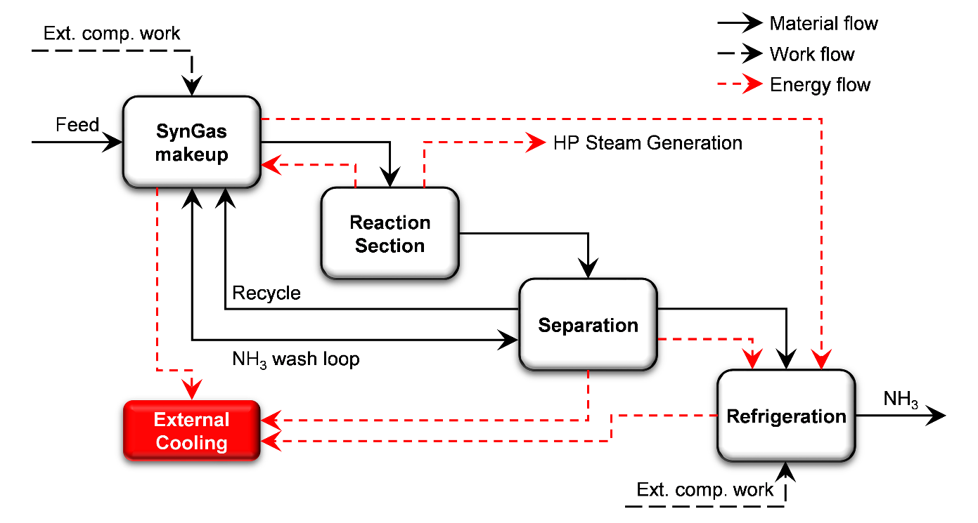
Figure 1: PFD for the synthesis loop of an arbitrary ammonia plant.

