

PROCESS SYSTEMS ENGINEERING

INTERSHIP REPORT

PRACTICING:

JESUS ERNESTO JIMENEZ AISPURO

SUBJECT:

DISTILLATION PROCCESES

PROFESSOR:

SIGURD SKOGESTAD

Trondheim, NORWAY July, 2013

### INTRODUCTION

We chose to simulate a real case in HYSYS in order to optimize the process, for that, we used a SRK Fluid package which is the suitable one for the case of gases such as Butane (D1), i-Pentane (D2) and n-Pentane (B2), being these the ones used in the Feed in this case.

We suppose the energy cost is relatively cheap and so, we can work at the maximum rate in each distillation column.

After running one time the simulation we are able to calcul the volatility constant (α), the overall separation factor (S) and the minimum number of trays (Nmin) as well as an approach to the real trays value (N = 3*Nmin) :

 

### 

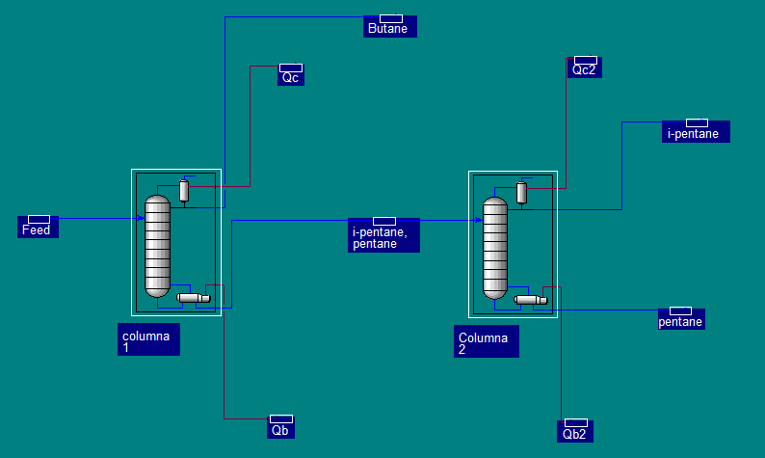Table 1. Process diagram containing the two distillation columns

We are looking for the optimal conditions to operate, by reducing the boiling reflux and obtaining as much product as possible. To be more exact we want to minimize the following cost:

J = PF*F + Pv*(V1 +V2) - PD1*D1 - PD2*D2 - PB2*B2

### CASE I: Pv = 0.001

In this case we are supposing very cheap energy, so we can operate at maximum reboiling flux for both columns (V1 and V2) , we have the constraint of XD2 = 0.95 which will always be active , so we have only 1 D.O.F left, so we chose to vary XD1 values to find out which one is the optimal one to operate in order to benefit more.

To resolve this optimization problem, we did a Case Study using UniSim tools; we introduced the formulas for J, so that we could see the evolution of Jdepending on the constraints.

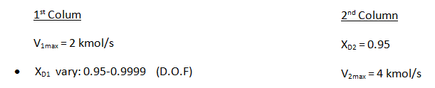

Prices estimated:

|  |  |
| --- | --- |
| PF | 0 |
| PD1 | 0 |
| PD2 | 1 |
| PB2 | 0 |
| PV | 0.001 |

### RESULTS

After doing the simulation we obtain the following plot in 2D:

In order to have a better look we used Log XA in B1 to plot it against cost function (J), we are able to read an optimal J when XA(B1)= 0.000007.

We divided the plot in 3 different regions, and located region 2 as the optimal work range, while in Region I we see we see the energy starts increasing too much, and finally in region III the distillation becomes unfeasible because it interfere with the requirements for column 2.

In this following plot we show a plot within the region I and II to have a closer look:

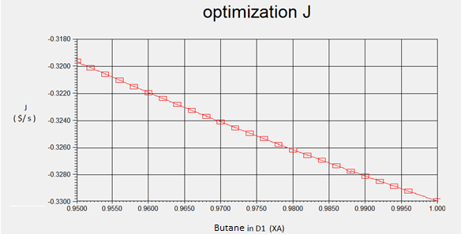  
 In this following plot we show a plot within the region II and III to have a closer look:

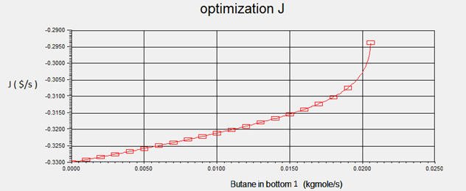

As we can see, we get better values for J when Butane in bottom or also called impurity in B1 (XB1i) gets closer to zero. Meaning we must benefice that energy is cheap and use maximum reboiling flux so we can over purify D1 in order to obtain more valuable product, in this case D2, and so, obtain a much better J.

### CASE II: Pv = 0.1

In this case we are supposing very expensive energy, so we are obligated to follow the minimum specifications for XD1, XD2. So that gives us two D.O.F. left ; in this case we are setting a fix value for XB1 and we will vary the value for XB2.

To resolve this optimization problem, we did a Case Study using UniSim tools as in Case I; we introduced the formulas for J, so that we could see the evolution of Jdepending on the constraints.

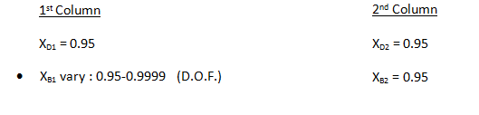

Prices estimated:

|  |  |
| --- | --- |
| PF | 0 |
| PD1 | 0 |
| PD2 | 1 |
| PB2 | 0 |
| PV | 0.1 |

### RESULTS

After doing the simulation we obtain the following plots in 2D:

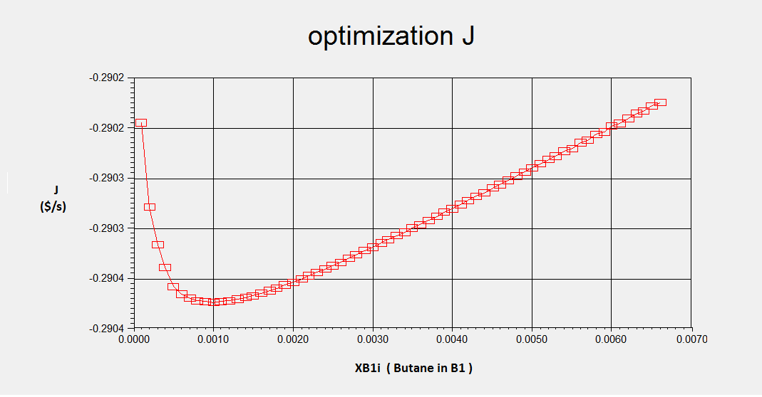

In this graphic we can easily identify the optimal value for XB1i to get the best value for J; this value is approximately XB1i = 0.001 which is in other words XB1 = 0.999, we obtain also the optimal values V1 = 0.682 and V2 = 3.65. All these values were obtained fixing the minimum required specifications for XD1, XD2 and XB2.

As we said at the beginning of case II, the energy is expensive, so we want to work using the less energy possible, avoid the “product giveaway” and work at ideal conditions to benefit more, which was this optimization problem’s goal.

### CASE III: Pv = 0.01

In this case we are supposing energy to have an intermediate value, so we are obligated to follow the minimum specifications for XD1, XD2.

To easy our work, we are dividing the results for each column, so we obtain:

J1 = PF*F + Pv*V1 + PD2*XDi*D1

J2 = Pv*V2 - PD2*D2 - PB2*B2

So that gives us two D.O.F. for each column; in this case we are setting fix values for XD1 and XD2 we will vary the value for XB1 and XB2.

|  |  |
| --- | --- |
| PF | 0 |
| PD1 | 0 |
| PD2 | 1 |
| PB2 | 0 |
| PV | 0.01 |

#### 1st Column

XD1 = 0.95

XB1 vary: 0.95-0.9999 (D.O.F.)

### Optimizing first Column

After doing the simulation we obtain the following plots in 2D:

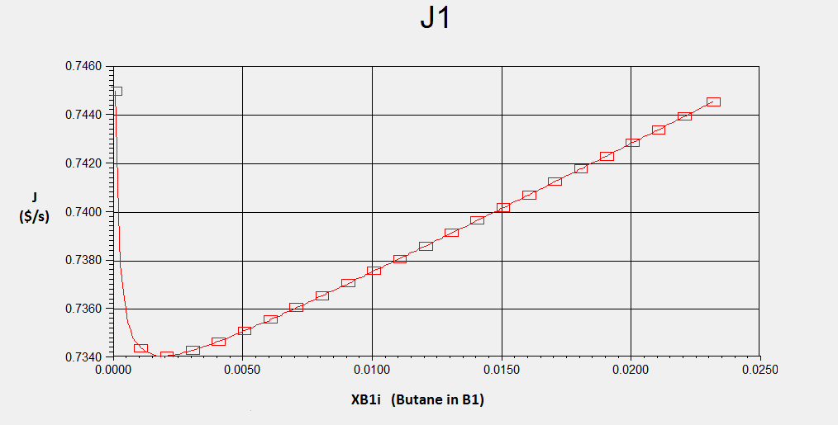

In this graphic we can easily identify the optimal value for XB1i to get the best value for J1; this value is approximately XB1i = 0.002 which is in other words XB1 = 0.998, we obtain also the optimal value V1 = 0.672. These values were obtained fixing the minimum required specifications for XD1.

#### 2nd Column

XD2 = 0.95

XB2 vary: 0.95-0.9999 (D.O.F.)

### Optimizing second Column

After doing the simulation we obtain the following plots in 2D:

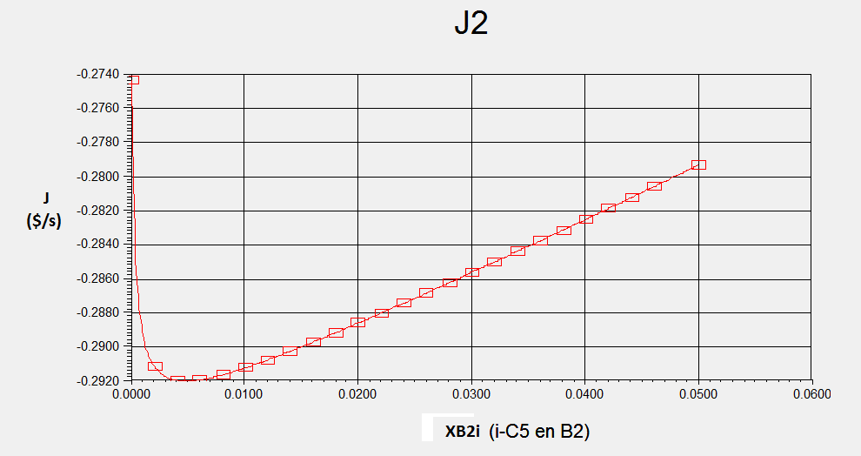

Here we can also identify the optimal value for XB2i to get the best value for J2; this value is approximately 0.0035≤ XB2i ≤ 0.006 which is in other words 0.994 ≤ XB1 ≤ 0.9965, we obtain also the optimal value 3.97 ≤ V2 ≤ V2max=4. These values were obtained fixing the minimum required specifications for XD2.

Note: We tested changing values for XD2 = 0.95,0.96,0.97,0.98 and 0.99 and we did not get better results for J2, because we are not being paid for a better purity of XD2 , instead, a better XD2 decreases the flow value for D2 , which is our main product and consequently decreases J value. This can be seen in the following plot:

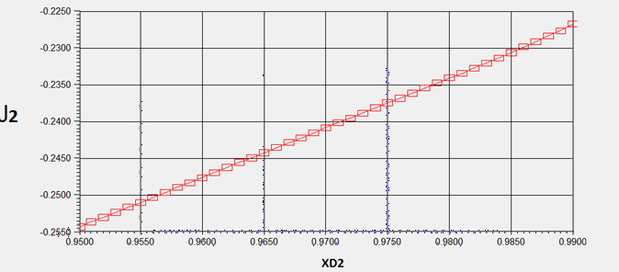

### 

### OVERALL RESULTS

At the end we simulated both columns at the same time, trying to obtain optimal values, and we found that the best value for J is obtained for XD1 = 0.95 and XD2 = 0.989, which is different from what we found in the previous plot for only J2.

|  |  |  |  |  |
| --- | --- | --- | --- | --- |
| 1st Column | |  | 2nd Column | |
| XD1 | 0.95 |  | XD2 | 0.989 |
| XB1 | 0.002 |  | XB2 | 0.0035 - 0.006 |
| V1 | 0.672 |  | V2 | 3.97 - 4 |

.   
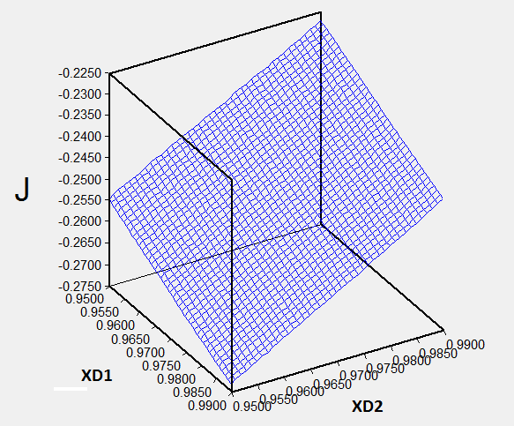

We have got the optimal values for working with both columns when we have an intermediate price for energy; the following table shows the results: