Variance minimizing control
K. Forsman, 2013-04-08
In applications, occasionally the control valve will saturate, i.e. go to 0% or 100%, in which case the controller is not active any more. Normally, this just means that we are facing a process design problem, and there is nothing to be done about the situation from a control point of view. However, in some applications it may be as important to reduce variations in the process variable as it is to keep its value close to the setpoint.
To solve this compromise we may consider to modify the working setpoint slightly so that we get back into a controllable situation, but also monitor when we can start gooing back to the target setpoint.
One of the simplest ideas for this is the structure showed in Figure 1. However, this structure does not work in practice.
Figure 1
If the structure is modified according to Figure 2 it can be made to work. Here F is a low pass filter.
Figure 2
Figure 3 shows a Simulink model for simulating various disturbance scenarios in the given structure.
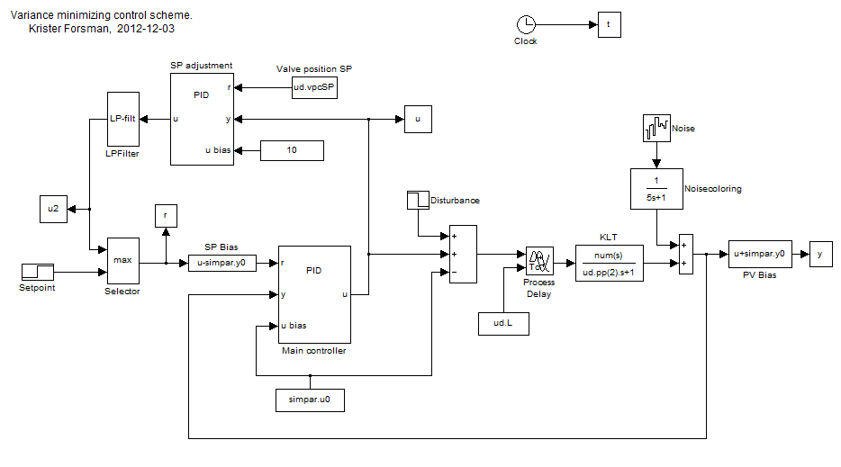
Figure 3
Figure 4 shows a simulation where a load disturbance occurs at time t=500. The PV variance initially increases, but after a while the working setpoint is modified, slowly, so that the valve is not saturated, and the variance is reduced.
Figure 4

There are a number of unanswered questions
- It is not clear if the idea is novel or not. A literature study would be of interest, to find out whether similar solutions have been proposed previously.
- Are there other structures that can do the same job?
- Prove that the suggested solution is stable, with proper choices of control and filter parameters.
- How should the low pass filter parameters be chosen, compared to the controller parameters to achieve a given compromise between variance reduction and setpoint following? Ideally, we can find a way of translating an optimization criterion to controller and low pass filter parameters.

