Some issues in ratio control
K. Forsman, 2013-04-08
Ratio control can be implemented in several different ways and the objective is to compare these. One issue is how we handle saturation, and another issue is how to handle nonlinearity caused by changes in the operating point.
Consider a classical ratio controller, as described by the block scheme in Figure 1.
Figure 1

Now suppose the slave loop control output saturates (the valve goes to 100%). In Figure 2, this happens at time t=37. As a consequence the slave PV does not reach its SP. However, the master loop gets no information about this, and thus the actual ratio deviates from the desired ratio.
Can the control scheme be modified, so that maintaining the ratio is prioritized, rather than master flow sticking to setpoint. How should this be done?

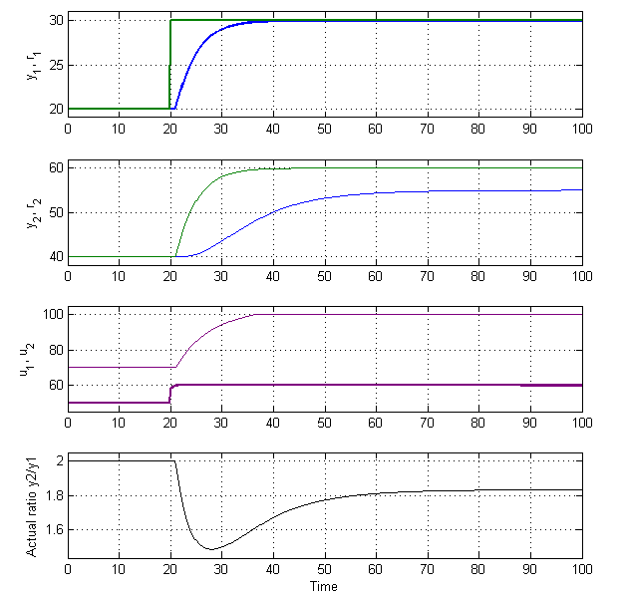
Figure 2: Ratio control. SP change in master loop. Slave OP saturates, and ratio goes wrong!

When there is a disturbance in the master process, and we use ratio against PV, then the slave process will follow the disturbance. The actual resulting ratio will get an S-shaped disturbance. Are there other ways of get rid of this, than just using SP-ratio instead? Figure 3.
The traditional ratio control schemes are just open loop setpoint calculations. Is there a structure that actually controls the ratio in feedback?

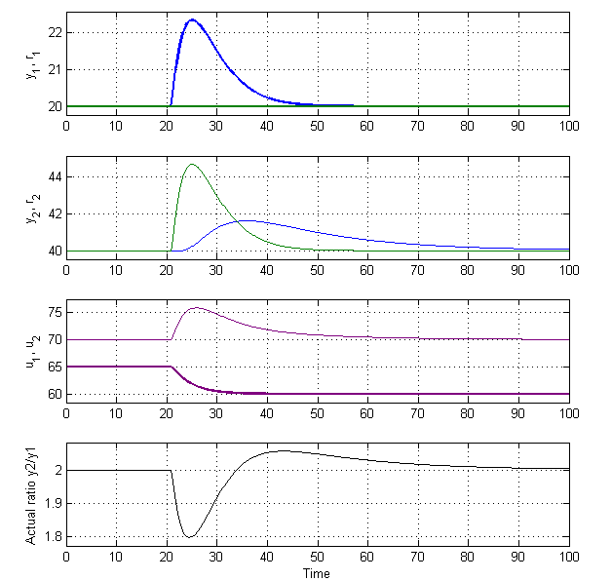
Figure 3: Ratio control against PV. Disturbance in master process. Ratio makes S-shaped excursion.

