Masteroppgaver våren 2016 for Sigurd Skogestad

Modelling, optimization and control of subsea separation
Co-supervisor: Christop Backi
This project is part of the SUBPRO project which is a new large research project in cooperation with Statoil, Shell, Engie, Lundin, Aker Solution, ABB and DNV GL.
The separation involves gas-liquid or liquid-liquid separation using gravity separators and/or cyclones. The model may be in Matlab, Hysys or Modellica.

Investigation of surrogate models with the Ammonia synthesis loop as case study.
Main supervisor: Sigurd Skogestad
Co Supervisor: Julian Straus
Optimal operation of existing plants is generally needed in highly competitive markets like the ammonia industry. This leads to highly integrated energy and material streams within the process. Most processes are modeled using a sequential-modular approach, in which unit operations (UO) are solved sequentially. Due to the integrated nature of the processes, solving a flowsheet can take long. In addition, flowsheet simulators are designed as black-box models which are not allowing the optimizer algorithm to access the underlying equations. As a result, optimal conditions are difficult to obtain.
Our idea to circumvent this problem is the introduction of surrogate models, which can be seen as defined auxiliary models mapping the process. The advantage is given by simplification and access to the mathematical foundation of the model. In addition, variable transformation and application of process knowledge can be utilized in defining the surrogate model. The core of the project is hence given by:
- Analysis of state-of-the-art approaches for steady-state optimization.
- Definition and design of the surrogate model.
- Implementation of a MATLAB/HYSYS interaction and analysis of the Model behavior.
- Definition of challenges and opportunities for future research.
This project requires basic knowledge in Aspen HYSYS and in optimization (TTK4135 Optimization and Control recommended, but not required. Advanced knowledge in MATLAB is additionally required.
The complete steady state model of the synthesis loop is already existing in HYSYS and will be used as starting point. This project is part of an industrial cooperation with Yara.
If questions arise and/or you are interested in the project, feel free to contact Julian Straus (julian.straus@ntnu.no, or pass by in room K4-239).
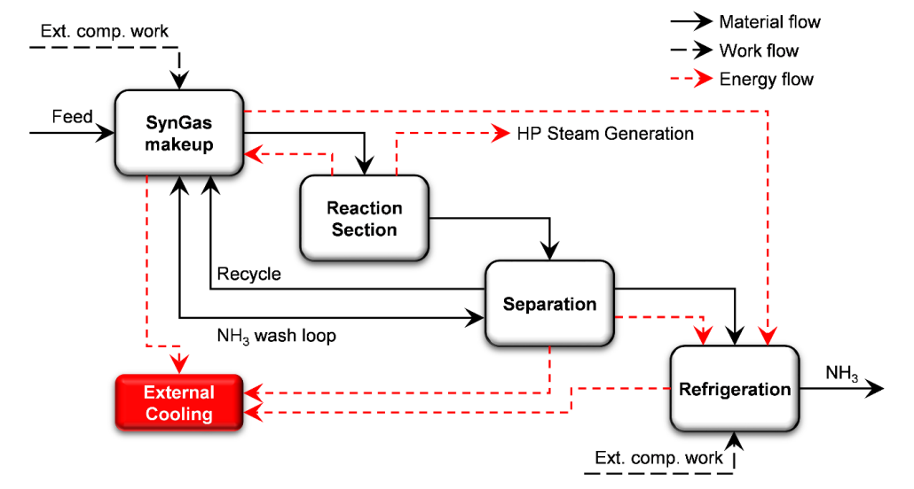

Title: Optimal operation of small LNG refrigeration cycles
Supervisor: Sigurd Skogestad (skoge@ntnu.no)
Co-supervisor: Adriana Reyes (adriana.r.lua@ntnu.no)
Natural gas is a fast growing energy resource in most regions of the world. Liquefaction plays an important role in the distribution of natural gas to locations in which pipeline transportation is not available. Boil-off gas (BOG) is the natural gas that boils-off during the voyage of a liquefied natural gas (LNG) carrier. Pressure in the tanks cannot exceed a certain limit and the common way to avoid overpressure is to burn BOG to onboard power steam turbines, or simply flare it. Small-scale LNG plants have been installed recently on LNG carriers to re-liquefy BOG, reducing product loss and minimizing flaring.
The majority of small LNG plants are either onboard carriers or in remote locations, where specialized staff might not be available and there might be limitations for obtaining continuous or reliable information regarding the process. This situation makes difficult to track changes in the process and to rely on onboard personnel to perform the appropriate adjustments every time a disturbance occurs.
The optimum operation point is determined by the natural gas feed composition and pressure, plant pressure, and ambient temperature. Ideally, refrigerant composition would be adjusted accordingly, but it is not a practical or even applicable solution.
This situation is an excellent example to explore the convenience of using self-optimizing control variables. The concept behind this is to maintain near-optimal (with acceptable loss) operation in presence of disturbances and implementation errors using constant set points (Skogestad 2000, 2004). In this procedure the identification of the steady-state degrees of freedom and the definition of the throughput manipulator (TPM) are important steps. It should be kept in mind that refrigeration processes are commonly closed systems and this brings additional challenges (Aske & Skogestad, 2009; Jensen & Skogestad, 2009).
Identifying the DOF for optimal operation is not always straightforward, partly because not all the physical DOF (“valves”) are used in the same way. Some DOF do not have steady state effect and these valves are only used for stabilization. Other DOF have a steady state effect and can be used for optimization; among these, some might be optimally constant.
The work proposed for this master thesis is to optimize the plant described by (Nekså et al. 2010). The student will use and probably improve a Matlab model that was developed during the specialization project. An important part of the analysis will be to identify the advantages and disadvantages of using the physical degrees of freedom in the mini LNG refrigeration cycle in different ways and to investigate the dynamic effects of the positioning of the TPM.
The student should have knowledge of optimization (QP, NLP). He/she should have experience using Matlab and preferably process simulators (e.g. HYSYS).
Reserved: Alexander Leguizamón

References:
Aske, E. M. B., & Skogestad, S. (2009). Consistent Inventory Control. Industrial & Engineering Chemistry Research, 48(24), 10892–10902. doi:10.1021/ie801603j
Jensen, J. B., & Skogestad, S. (2009). Steady-State Operational Degrees of Freedom with Application to Refrigeration Cycles. Industrial & Engineering Chemistry Research, 48(14), 6652–6659. doi:10.1021/ie800565z
Nekså, P., E. Brendeng, M. Drescher, and B. Norberg. 2010. “Development and Analysis of a Natural Gas Reliquefaction Plant for Small Gas Carriers.” Journal of Natural Gas Science and Engineering 2(2-3): 143–49. http://www.sciencedirect.com/science/article/pii/S1875510010000326 (January 20, 2015).
Skogestad, Sigurd. (2000). “Plantwide Control: The Search for the Self-Optimizing Control Structure.” Journal of Process Control 10(5): 487–507. http://dx.doi.org/10.1016/S0959-1524(00)00023-8 (December 3, 2013).
Skogestad, S. (2004). Control structure design for complete chemical plants. Computers & Chemical Engineering, 28(1-2), 219–234. doi:10.1016/j.compchemeng.2003.08.002

Title: Dynamisk regulering av anlegg for produksjon av flytende hydrogen
Mye av vinden som blåser over Varangerhalvøya kan konverteres til elkraft, men det finnes ikke kapasitet i nettet for å eksportere kraften. Derimot har japansk industri vist interesse for å benytte denne strandede vindenergien til storskala hydrogenproduksjon og –eksport til Japan (gjerne via nordøstpassasjen).
Hydrogen genereres av strøm og vann via elektrolyse, og så gjøres flytende for transport i store tankskip. Disse er i dag fortsatt ved konseptstadiet, men store industrikonsern som Kawasaki har vist interesse i idéen.
Det ble nylig utviklet avanserte løsninger for anlegg for produksjon av flytende hydrogen, mest relevant i EU-prosjektet IdealHy, som vil være startpunkt for oppgaven. SINTEF deltok i prosjektet med partnere som Shell, Linde, TU Dresden og Kawasaki, og kan gi tilgang til data, modeller og kontaktnettverk.
Det er en kjent problematikk innad IdealHy at prosessen de utviklet er riktignok mye bedre enn tidligere metoder, men krever stasjonære betingelser. Dette er ikke realistisk i forbindelse med store vindparker, da deres effektproduksjon vil variere sterkt fra time til time, med kort eller ingen varsel i endringer.
Oppgaven går altså ut på å:
• Modellere et stort anlegg for hydrogenproduksjon, flytendegjøring og eksport, med basis i IdealHy;
o Programmeringsspråk kan være Python, Modelica, Matlab eller hva kandidaten er best i.
• Gjøre de nødvendige endringer i modellen for å gjøre den dynamisk;
• Evaluere anleggets dynamiske egenskaper, spesielt med hensyn på raskt varierende tilgang på kraft;
• Definere en reguleringsstrategi som muliggjør dynamisk drift av anlegget, herunder anleggsmodifikasjoner som bufferenheter, valg av egnede enhetstyper (f.eks. PEM vs. alkaliske elektrolysører), systemredundans / pålitelighet;
• Ta hensyn til sammenhengen i Varangerhalvøya: mulighet til å benytte lokal vannkraft for lagring, begrensninger på eksport, mm.

Oppgaven kan gjerne fokuseres på noen spesifikke områder etter kandidatens ønske (i samråd med veiledere).

Krav: interesse for og kompetanse i dynamisk modellering / simulering, samt relevant erfaring i programmeringsspråk (hvilke er ikke så viktig, men Modelica er nok en fordel). Gode kunnskaper i engelsk da mye av dokumentasjonen er fra internasjonale prosjekter.
Faglærer: Sigurd Skogestad
Medveiledere: Steffen Møller-Holst, Markedsdirektør for hydrogen i SINTEF; Federico Zenith, seniorforsker i SINTEF.

