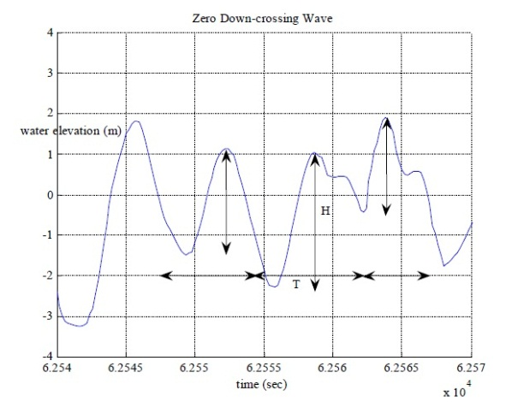**Measuring Ocean Waves Using GPS Buoy**

This flyer shows the analysis of wave data measured by a single low-cost GPS buoy. Figure 1 shows the basic definitions for the wave height and wave period in a short record of a wave measurement.

**Research Concepts:**

The application of the high-pass filtering to GPS data in conjunction with the directional wave spectral theory is core concept (See Figure 5).

**GPS Input Data:**

GPS Coordinates including:

* Longitude
* Latitude
* Height

**Wave Statistical Analysis:**

Wave heights, Mean zero-crossing period and other wave parameters are determined directly from high- pass filtered GPS height time-series through zero down- or up cross analysis (See Figures 1 and 5).

**Directional Spectral Analysis:**

Wave directions are determined by Fast Fourier Transformed (FFT) signals (high- pass filtered GPS height, east and north time-series), which is the energy content at each predefined frequency (See Figures 2 and 3).

Figure 1. Defining zero down-crossing waves of a short record of wave measurements

Figure 2. Power spectrum of the GPS height data (in m2 /Hz)

Figure 3. Directional wave spectra of the GPS buoy data

**Deliverables:**

* **Wave Height**
* **Wave period**
* **Wave Direction**

Other wave parameters can also be delivered by this method like: Significant wave height, Significant wave period, Peak Period, Mean wave Direction and Spreading. Also one can reconstruct the waveform by GPS buoy.

Figure 4 shows the moored-sea GPS buoy used in Taiwanese coastline.

Figure 5 depicts the filtered GPS height data of the moored-sea GPS buoy in Taiwanese coastline.

Table 1 shows the wave parameters estimated in the Taiwanese coastal area by the moored-sea GPS buoy. Figure 3 shows the directional spectral polar plot of the same GPS buoy.

**For more information, please contact Professor Hossein Nahavandchi** ([hossein.nahavandchi@ntnu.no](mailto:hossein.nahavandchi@ntnu.no))

****

Figure 4. The GPS buoy in Taiwanese coastline

buoy0930_Z.eps

Figure 5. GPS Heights of moored-sea GPS Buoy after filtering

Table 1. Wave parameters estimated from the moored-sea GPS buoy in Taiwanese Coastal region

|  |  |
| --- | --- |
| Wave Parameters | Result |
| Wave Height | 17 cm |
| Wave period | 18.78 sec |
| Wave direction | 226.5 degree |